**Denagene Tajhiz Company**

**Biotechnology Lab Equipment manufacturer and designer**

Power Supply - DGT-Universal Model

User Guide

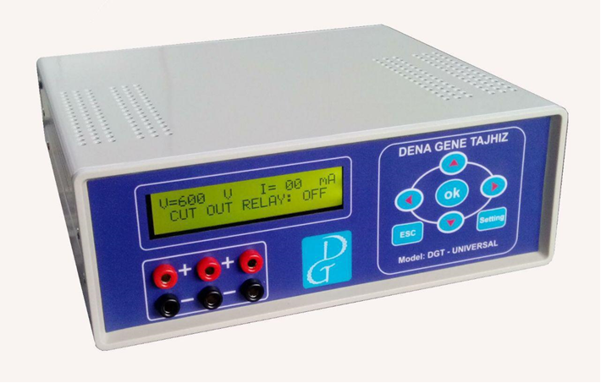

Thanks for choosing Denagene Tajhiz Power Supply. This operation manual describes the function of the instrument. To ensure you can correctly operate the instrument, please read the manual carefully before using it. Please keep this manual properly for later use if you encounter any difficulty. The first time opening the packing, please check the instrument and appendix with the packing list. If anything does not match with the packing list, please contact us.

This manual is a valuable resource for all users of our products, whether you are a seasoned professional or just starting your scientific journey. It has been meticulously crafted to ensure that you clearly understand the features, functionality, and proper usage of our laboratory equipment.

Within these pages, you will find detailed instructions, diagrams, and troubleshooting guides that will assist you in harnessing the full potential of our products. We have taken great care to ensure that the content is organized logically, making it easy for you to navigate through the manual and locate the information you need quickly.

Moreover, this manual is a living document that reflects our ongoing commitment to excellence. As we continue to develop and improve our product offerings, we will provide updates and revisions to this manual to ensure that you always have the most up-to-date information at your fingertips.

Reproduction in any form, whether print or electronic, without written permission from Denagene Tajhiz Company, is strictly prohibited.

Introduction

Safety Instruction

Device components

Technical specifications

Set up and Installation

Power adjustment

Setting the power to cut off the current after the end of the test time

Setting the power operation duration

warranty

**Introduction**

The DGT-UNIVERSAL power supply device for electrophoresis, manufactured by Denagene Tajhiz Company, is designed with high precision, quality, and high safety features. It is capable of supplying voltage from 0 to 600 volts with an accuracy of 1 volt, and current from 0 to 400 milliamperes with an accuracy of 1 milliampere, making it competitive with the best brands in the world. As the name suggests, this device is used to supply voltage for the following techniques:

SDS-PAGE (Polyacrylamide Gel Electrophoresis)

Native Page

Agarose gel electrophoresis

DNA pulsed field electrophoresis

Electroblotting (including wet transfer and semidry transfer)

Denaturing Gradient Gel Electrophoresis (DGGE)

Additionally, this device is suitable for techniques such as IEF (Isoelectric Focusing) and DNA sequencing. Although this power supply apparatus is primarily used to regulate the applied current and voltage in the electrophoresis environment, it can also be used in other settings where cathodes, anodes, and specific current and voltage settings are required. Therefore, other specialists, especially analytical chemists, also extensively utilize this apparatus.

**Safety Instruction**

Considering that the device is capable of delivering sufficient voltage and current to create a hazardous shock, it is strongly recommended that users adhere to the safety precautions associated with it. To prevent any potential hazards, it is strongly advised that only trained and qualified individuals, based on the device's instructions for use, should operate it.

Only use fully insulated and standardized connector cables and power cords.

Always keep the device dry and clean.

Never use the device in excessively humid environments.

To ensure the cooling of the device, always make sure that the ventilation areas located on the sides of the device are not covered.

The DGT Universal power supply apparatus for electrophoresis is designed for use within a temperature range of 0 to 40 degrees Celsius and a relative humidity of 20 to 80 percent. Denagene Tajhiz Company does not endorse using the device under conditions outside of these specifications.

**Device Components**

The device includes:

1-Display (Voltage, Current, Time)

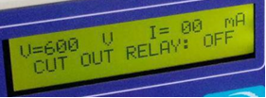

2. Panel Keypad (including Up and Down arrows, Left and Right arrows, Ok, Setting, ESC)

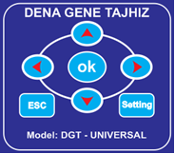

3. Triple Output Terminal: The red outputs are for the positive pole, and the black outputs are for the negative pole. To drive electrophoresis or blotting, a dual-ended connector cable should be connected to one positive output and one negative output.

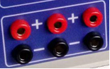

4. 3 Amp Input Fuse (rear of the device)

5. 0.5 Amp Output Fuse (rear of the device)

6. 220V Power Input (rear of the device)

7. Power Button (turning the device on and off, located on the rear of the device)

Technical Specification

|  |  |
| --- | --- |
| **Technical Specification** | |
| Simultaneous Connection Capacity | 3 |
| Output voltage | 0-600 V |
| Current | 0-400 mA |
| Maximum Output Power | 240 W |
| Timer | 1min- 99:59' Hours |
| Voltage Accuracy | 0.1 V |
| Current Accuracy | 0.1 mA |
| Efficiency | 95 % |
| Dimensions | 22x20x8 cm |
| Weight | 1.8 kg |
| Operating Temperature | 0-50 C |

**Set up and Installation**

How to Operate the Apparatus:

• Before turning on the apparatus:

1. Connect the power cord to the back of the apparatus (ensure that the voltage and current knobs are turned off).

2. Then, use the power button on the back of the apparatus to turn it on.

At this point, when the electrophoresis tank is not connected to the power, the display will show a voltage of 24 volts and a current value of zero.

Next, connect the electrophoresis tank to the apparatus (pay attention to the polarity of the connector cable and the power ports when connecting the electrophoresis tank).

In general, the settings of the DGT Universal power supply apparatus are performed in three steps:

A. Setting the voltage or current.

B. Turning the current relay ON or OFF.

C. Setting the duration of apparatus operation.

These steps will be explained in detail below.

Power Setting is done in two ways:

1. Setting based on voltage mode (constant voltage)

2. Setting based on current mode (constant current)

1. Setting Power in Voltage Mode (constant voltage):

In cases where a specific voltage is desired, press the setting button, then use the Left and Right arrows on the keypad to select the voltage item. Adjust the desired voltage value using the Up and Down arrows on the keypad, and then press the OK button to save the set voltage.

Note that by adjusting the voltage, the current will change proportionally to the set voltage. If the device is set to a specific current, the voltage will change proportionally to the set current, and no further adjustment is required by the user.

2. Setting Power in Current Mode (constant current):

In cases where a specific current is desired, press the setting button, then use the Left and Right arrows on the keypad to select the current item. Adjust the desired current value using the Up and Down arrows on the keypad, and then press the OK button to save the set current.

Please note that when adjusting the voltage of the device, the current will change proportionally to the set voltage. If the device is set to a specific current, the voltage will change proportionally to the set current, and no further adjustment is required by the user.

2. Setting power based on current (constant current):

In cases where a specific current is desired, press the setting button, then use the Left and Right arrows on the keypad to select the current item. Adjust the desired current value using the Up and Down arrows on the keypad, and then press the Ok button to save the set current.

**Setting the power operation time:**

To do this, you need to set the device's CURRENT RELAY system from OFF to ON mode.

After setting the desired current or voltage and pressing the OK button, enter the CURRENT RELAY system. Then, select the ON option using the Up and Down buttons, and press the OK button once to confirm.

**Setting the power operation time:**

After setting the CURRENT RELAY power, you will enter the time-setting phase. You can adjust the desired time using the Left and Right buttons on the panel. Then, press the OK button once to save the desired time, and the apparatus will start operating. The most important indicator of the device's operation is observing the amount of current passing through the power source using the CURRENT item on the LCD. If the current displays a numerical value other than zero, the device is active. Sometimes, due to encountered issues, the apparatus may display a specific number for voltage and current, but no significant event occurs due to the lack of current flow. However, a simple way to check is by observing the presence of bubbles in the buffer. If bubbles are present, the device is applying voltage and current.

The power supply of the electrophoresis system manufactured by Denagene Tajhiz is designed to be resistant to input fluctuations and disturbances. When the voltage or current exceeds the device's capacity (above 600 volts or 400 milliamps), the power supply will prevent the passage of higher currents and display zero values for the current and voltage.

At this point, the maximum current (400 milliamps) should be applied using the current mode to determine the maximum voltage that can be set when a load (such as an electrophoresis tank) is connected. This means that if the voltage exceeds this threshold, it indicates a current higher than the device's standard (400 milliamps), which the apparatus does not allow.

Therefore, in cases such as changing buffer properties, malfunctions in devices connected to the power supply, and so on, potential issues may arise.

Please note that in the event of a short circuit, the apparatus will automatically shut down to prevent damage.

If you encounter any problems with device settings, turn off the power switch at the back of the apparatus and restart it after a few seconds. Occasionally, the power supply's processing system may become disrupted due to applied noise, and a reset is necessary.

**Warranty:**

• As stated in the warranty card for the DGT Universal Electrophoresis Power Supply apparatus, it has a one-year warranty and 10 years of after-sales service.

• In case of any issues with the device, without attempting any non-professional repairs, send it to the company's address and wait for the apparatus to be repaired by the after-sales service unit.

**Documentation and Support**

To obtain support for the latest services and support information for all locations, go to:

[www.Denagene.com](http://www.Denagene.com)

At the website, you can:

• Access worldwide telephone and fax numbers to contact Technical Support and Sales facilities

• Search through frequently asked questions (FAQs)

• Submit a question directly to Technical Support

• Search for user documents, SDSs, vector maps and sequences, application notes, formulations, handbooks, certificates of analysis, citations, and other product support documents

• Obtain information about customer training

• Download software updates and patches