**Denagene Tajhiz Company**

**Biotechnology Lab Equipment manufacturer and designer**

**DeNA Cycler 32 Eco**

**User Guide**

DeNA Cycler 32 Eco

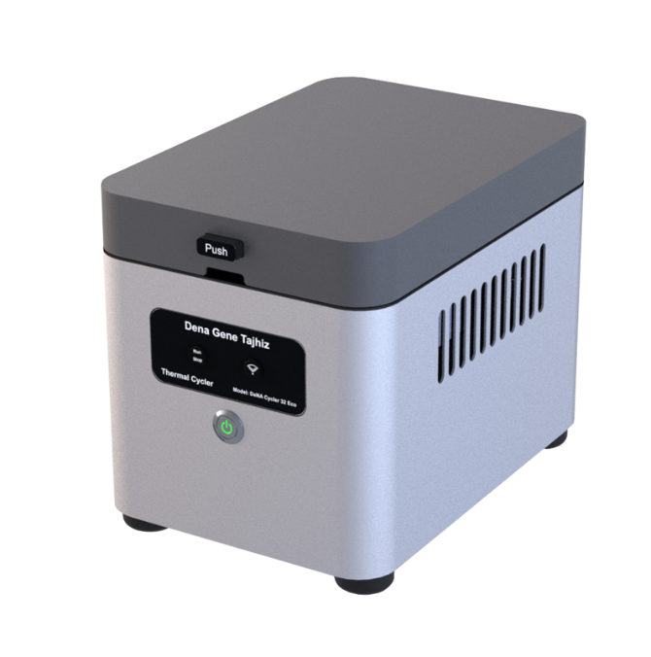

Thanks for choosing The Denagene Tajhiz Company’s DeNA Cycler Eco. This operation manual describes the function of the instrument. To ensure you can correctly operate the instrument, please read the manual carefully before using it. Please keep this manual properly for later use if you encounter any difficulty. The first time opening the packing, please check the instrument and appendix with the packing list. If anything does not match the packing list, don't hesitate to get in touch with us.

This manual is a valuable resource for all users of our products, whether you are a seasoned professional or just starting your scientific journey. It has been meticulously crafted to ensure that you clearly understand the features, functionality, and proper usage of our laboratory equipment.

Within these pages, you will find detailed instructions, diagrams, and troubleshooting guides that will assist you in harnessing the full potential of our products. We have taken great care to ensure that the content is organized logically, making it easy for you to navigate through the manual and locate the information you need quickly.

Moreover, this manual is a living document that reflects our ongoing commitment to excellence. As we continue to develop and improve our product offerings, we will provide updates and revisions to this manual to ensure that you always have the most up-to-date information at your fingertips.

Reproduction in any form, whether print or electronic, without written permission from Denagene Tajhiz Company, is strictly prohibited.

Introduction

DeNA Cycler 32 ECO

PCR Condition

Thermal Cycler

Warning

Set up and Installation

Components of Apparatus

Technical Specification

Set up and Installation

Important Points

Maintenance

Application

Warranty and After-Sales Service

**Introduction**

Thermocyclers are widely used in molecular biology, clinical diagnosis, criminal investigation, and infectious disease research, among other fields. They are essential laboratory equipment for researchers who run polymerase chain reactions (PCR) for sequencing, cloning, genotyping, mutagenesis, and many other applications. Denagene Tajhiz Company has designed and produced both a non-gradient and a gradient thermocycler. The company has also produced an economical PCR device, called DeNA Cycler 32 Eco. Educational, scientific, and research centers can provide this model of thermocycler at a low cost.

**Economic Thermocycler (DeNA Cycler 32 Eco)**

For studying molecular processes within cells, the most important option is to examine nucleic acids. In the typical condition, all stages of DNA replication within a cell occur at a temperature of 37 degrees Celsius. This complexity arises from the intricate mechanisms involved in replication within living organisms, which require a large number of components. However, outside of the cell, it is not feasible to assemble all these variables, and even if it were possible, it would be extremely expensive.

Moreover, considering the low initial quantities of nucleic acids, it is necessary to amplify them to a reasonable level for use and analysis. To address this, researchers discovered a thermo-stable DNA polymerase enzyme capable of withstanding high temperatures while remaining functional. Additionally, it was previously known that the connection between two strands of DNA occurs through hydrogen bonds, which can be disrupted and "melted" by increasing the temperature. The melting and subsequent cooling of DNA, along with the inclusion of primers (oligonucleotides specific to the target DNA region), provide the conditions for DNA replication.

All of these DNA replication processes, utilizing the temperature-dependent properties of DNA, can occur repeatedly in a reaction called Polymerase Chain Reaction (PCR). During the PCR process, nucleic acids are replicated to a sufficient quantity. This process involves DNA templates, primers, a DNA polymerase enzyme, a master mix, and cycling temperatures. The cycling temperatures facilitate denaturation, annealing, and extension at the optimal temperature for the activity of the DNA polymerase enzyme.

To perform these cycling temperatures, an apparatus called a thermocycler is necessary. The thermocycler, also known as a PCR machine, utilizes the polymerase chain reaction technology to carry out this process optimally. By amplifying DNA, various downstream processes such as diagnostics, cloning, genotyping, and sequence determination can be easily performed.

The thermocycler itself comes in various types, including simple and gradient models, both of which are manufactured by Denagene Tajhiz Company. In this case, we aim to provide a guide for using the DeNA Cycler 32 Eco, a standard thermal cycler model that comes with software installed on a computer. The apparatus can be controlled using Wi-Fi or a USB cable connection.

**PCR Technique**

PCR (Polymerase Chain Reaction) is a technique that replicates DNA outside of a living organism, but the goal is not to replicate the entire DNA. The objective is to amplify millions of copies of a specific gene. In essence, PCR is an in vitro replication that occurs outside of the cellular environment. The difference between PCR and in-cell replication is that PCR takes place outside of the cell and is selective, amplifying only a specific sequence. In contrast, in-cell replication replicates the entire cellular genome.

**Applications of PCR:**

PCR has various applications, including:

1. Gene amplification: PCR is utilized to produce multiple copies of a specific gene for further analysis or manipulation.

2. Prenatal genetic testing: PCR can be used to diagnose genetic diseases in embryos or fetuses before birth.

3. Gene presence/absence detection: PCR enables the determination of whether a specific gene is present or absent in a cell or organism.

4. Fetal sex determination: PCR can be employed to determine the sex of a fetus.

5. Archaeology: PCR techniques can assist in DNA analysis of ancient samples for archaeological studies.

6. DNA sequencing: PCR plays a crucial role in DNA sequencing methods, allowing the determination of the order of nucleotides in a DNA molecule.

7. Chromosomal disorder diagnosis: PCR-based methods are used to detect chromosomal abnormalities or disorders.

8. Genetic fingerprinting: PCR facilitates genetic fingerprinting, which is used in forensic investigations and paternity testing.

9. Evolutionary studies: PCR is employed in studying the genetic relationships and evolutionary processes of organisms.

10. PCR in disease diagnosis: PCR has revolutionized the diagnosis of genetic diseases. It can detect mutations and diseases such as hemophilia, AIDS, sickle cell anemia, cystic fibrosis, thalassemia, tuberculosis, Duchenne muscular dystrophy, phenylketonuria, and more. PCR exhibits a sensitivity that is ten thousand times higher than conventional methods.

**PCR Conditions:**

To carry out PCR, certain conditions need to be met. The two DNA strands must separate to allow the primers to bind in their correct positions and initiate replication. In cells, the helicase enzyme is responsible for this task. However, in PCR, helicase enzyme is not added because when the temperature rises to 95°C, the hydrogen bonds break, and the two strands separate. This phenomenon is referred to as DNA melting. In PCR, the stage of separating the two DNA strands is called denaturation (Figure 1).

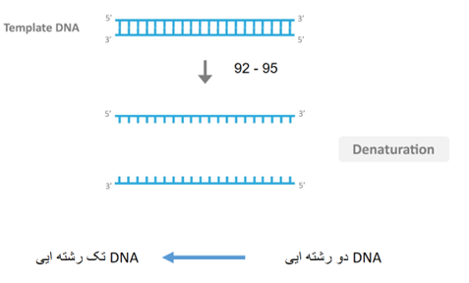

The stage of separating DNA strands is known as denaturation.

Annealing Temperature is the temperature at which the primers bind to the target sequence in a specific manner. When the primers attach to the desired sequence, they create a 3' OH end, which allows the DNA polymerase to add nucleotides to this end (Figure 2).

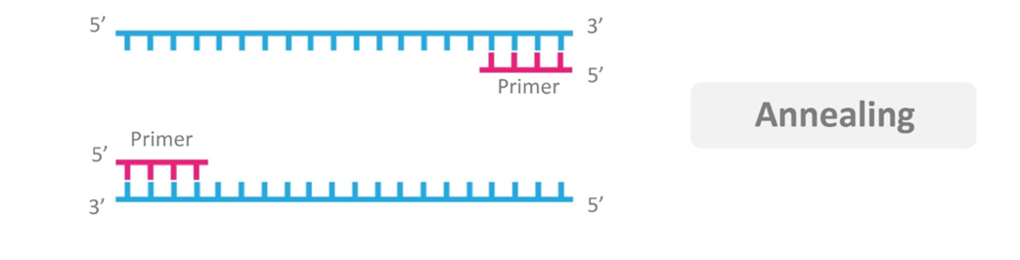

After the primers have annealed to their specific positions, the replication process needs to occur. This stage of PCR is called extension. During this stage, the temperature is raised to 72°C, as DNA polymerase exhibits its highest efficiency and replication speed at this temperature. There is no need to remove the primers since they are made of DNA (Figure 3).

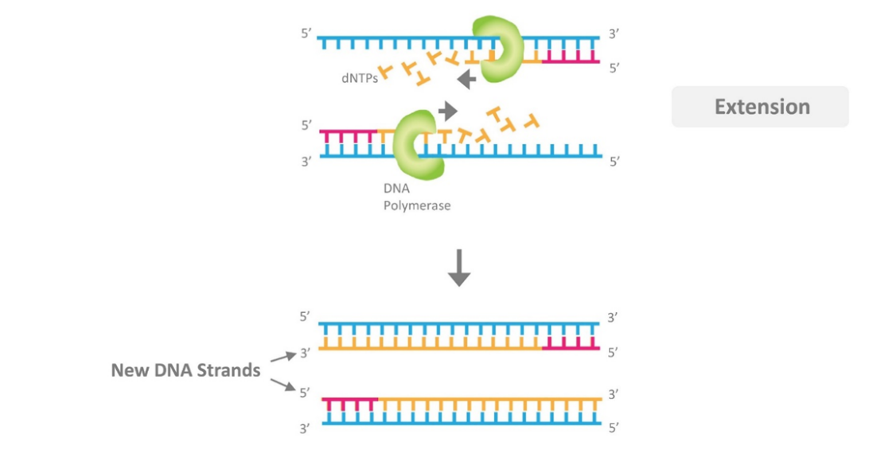

Figure 3. DNA Molecule Amplification Stage

The extension stage has a specific duration, which is determined based on the length of the target fragment. For every 1000 base pairs (bp), one minute is typically allocated for this stage.

In summary, the main stages of a PCR reaction are as follows:

1) Denaturation:

- The two DNA strands separate at a temperature of 94-95°C for 30-60 seconds.

- Extending the duration of this stage does not provide any benefits to the reaction, except for reducing the activity and half-life of the Taq polymerase enzyme.

2) Annealing:

- Primers bind to complementary regions on the DNA and determine the replication range.

- This stage occurs at a temperature of 40-60°C.

- A suitable and sufficient time of 30-60 seconds is allocated for each primer pair.

3) Extension:

- The target DNA fragment is replicated at a temperature of 72°C for a duration of 5 to 15 minutes.

- For a 1 Kb fragment, a time of 1 minute is typically sufficient.

These three stages are repeated between 25 to 35 cycles, which are referred to as PCR cycles. After 35 cycles, the number of replicated fragments reaches approximately 68 billion copies (Figure 4).

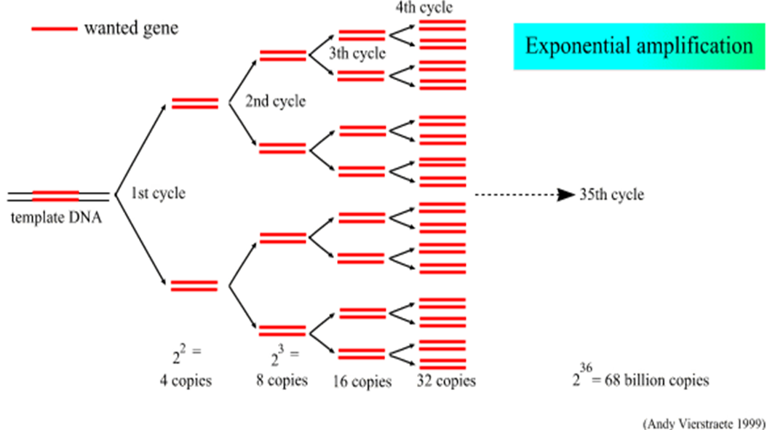

**Figure 4. Exponential Amplification of DNA Molecules**

A thermal cycler, also known as a PCR machine, is a crucial tool for studying molecular processes within cells, especially nucleic acids. Due to the low initial quantity of nucleic acids, it is necessary to amplify them to an acceptable level for analysis and investigation. The polymerase chain reaction (PCR) process allows for sufficient replication of nucleic acids. This process involves DNA templates, primers, Taq polymerase enzyme, master mix, and temperature cycling. The temperature cycling is essential for denaturation, annealing, and extension to occur at the optimal temperature for the activity of the polymerase enzyme. To perform these temperature cycles, a device called a thermal cycler is used.

The thermal cycler, or PCR machine, utilizes the polymerase chain reaction technology to carry out the process efficiently. It comes in various types, including simple and gradient models. In the simple mode, the samples can be subjected to a specific temperature simultaneously. In the gradient mode, multiple temperatures can be applied simultaneously. The gradient function in a thermal cycler is particularly useful for optimizing the annealing temperature. Denagene company has designed and produced both regular PCR and gradient PCR models.

In this context, the focus is on providing a guide for using a regular thermal cycler, where its software is installed on a connected computer. The device can be controlled using Wi-Fi or a USB cable.

**Warning**

* Due to rapid temperature changes in the PCR instrument, the user mustn't touch the reaction block surfaces.
* Connect the instrument only to the appropriate power source.
* Connect it only to a power source that provides a secure grounding.
* This instrument has a high power consumption, so only use the main cables that have been tested for electrical power connection.
* It is the user's responsibility to ensure the protection of the hazardous materials on or inside the instrument.
* In case of contamination, clean it only with a damp lint-free cloth. Do not use chemical cleaning agents.

**Set up and Installation**

Regardless of the model, the PCR device comes with a user manual, a power cord, the PCR machine itself, and protective foam. Carefully remove the device from its packaging and inspect it.

If there is any damage to the device, report it to Denagene Tajhiz Company immediately.

If there are any issues, keep all packaging materials with you.

If there are any physical problems, do not attempt to use the device. Instead, contact the company as soon as possible.

**Components of PCR System:**

* Reaction Block: Where the samples are placed
* Heat Lid: Used to heat the samples to a high temperature. This action applies thermal pressure to the samples and prevents evaporation and dispersion of the reaction tube contents.
* USB Port: Used for connecting the command interface cable and running the reaction.
* Power Button: Used to turn the device on and off.
* Pause/Run Button: Used to pause and resume the reaction.
* Ventilation Pathways: Used for device ventilation.
* Device Wi-Fi: Used for establishing communication with a computer and device software.

**Usage Instructions:**

To use the device, first connect the power cord to the electrical outlet. Make sure that the space around the PCR device is not enclosed, as proper air ventilation is crucial for the device. Turn on the device using the power button located on the front, and allow the device to load.

Once the device is powered on, the user can directly access the editor menu and define a new reaction. Alternatively, they can connect the device to a Wi-Fi or USB using one of the connection methods and run their program.

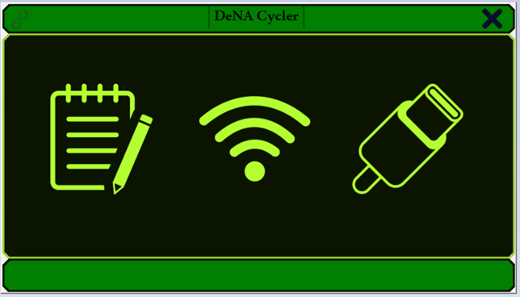

Figure 5. DeNA Cycler Software Main Menu

If the user wants to define a new reaction, they can start by accessing the editor menu. To connect via Wi-Fi, first turn on the Wi-Fi button on the device to enable antenna functionality. After that, connect your computer to the device's Wi-Fi by following the steps below. Once you are confident in the computer's connection to the Wi-Fi, click on the Wi-Fi tab in the software to establish the connection between the software and the device.

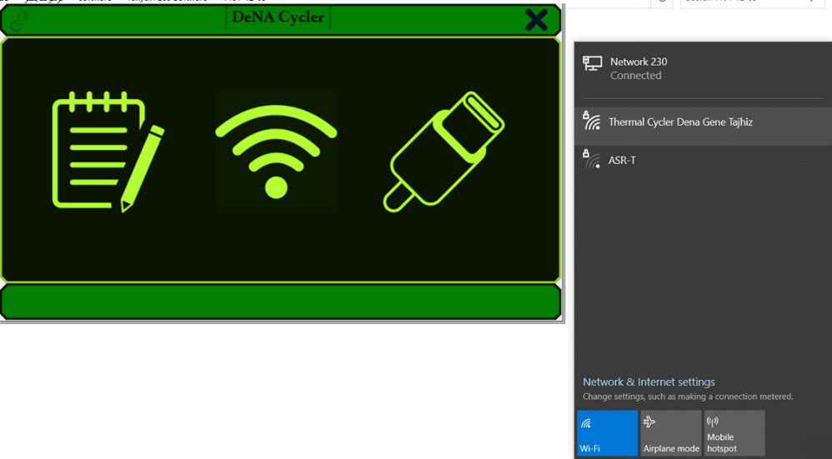

Figure 6. Process of Connecting to the Wi-Fi of the Thermal Cycler Device with the Software

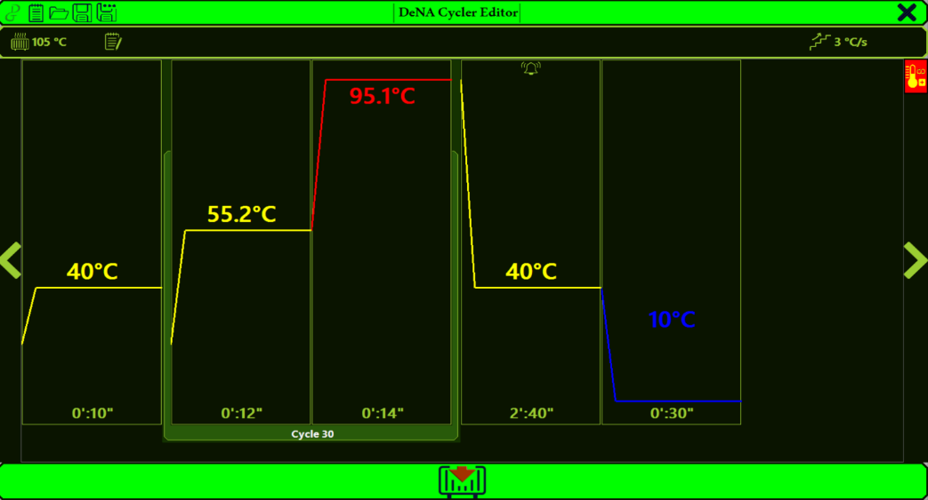

Figure 7. Initial Menu of the Editor Software. The header color in this software is light green, while the running menu color is dark green.

In this menu, the user can implement the reaction ramp rate, and the temperature of the heat lid, define reaction steps, and specify reaction cycles.

D:\نمایشگاه\دوره 10\ترموسایکلر ECO 32\manual pictures\6.png

Figure 8. Temperature Control and Reaction Ramp Rate Menu Bar

To decrease or increase the reaction steps, the user can click on the step that needs modification, and the corresponding tabs for that step will illuminate. As visible in the image below, on the top left, there is an icon to delete the step, on the top right, there is a temperature icon to add a new step, and three dots to add alarms and a new cycle to the reaction.

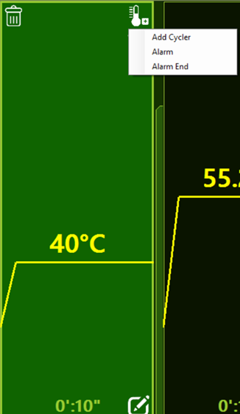

Figure 9. How to Apply Settings for Each Step and Add Reaction Variables

However, the pen icon at the bottom right is for changing the time and temperature parameters related to the step. By clicking on it, the user can adjust the temperature and duration of the step.

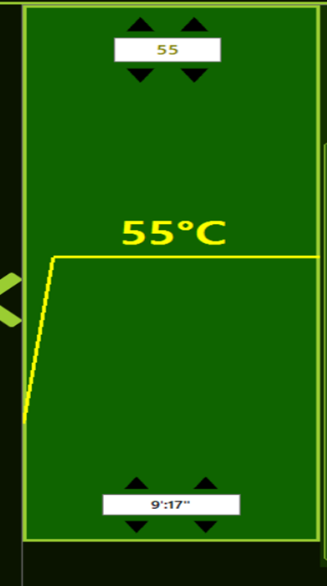

Figure 10. Reaction Step Settings

Important Note: The default heat-lid temperature is set to 105 degrees Celsius, and the user should not assign a different temperature for PCR reaction to the heat-lid. This is because it will affect the device's temperature calibration.

The ramp of the device is locked at 4 to ensure a longer lifespan of the components, preventing the user from defining a higher ramp rate.

However, the variables for each step in the cycle have different values than the variables for steps outside the cycle. Inside the cycle steps, instead of adding a cycle, a touch step has been added, allowing the user to define a touch-down or touch-up step using this method.

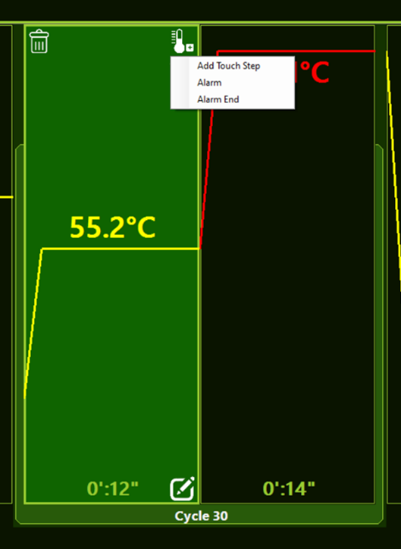

Figure 11. Variables for Steps Inside the Cycle

By clicking on the border bar of the cycles, the user can change the number of cycles. Additionally, by clicking on the three dots, they can create a new cycle, delete a cycle, and create a new step outside the cycle.

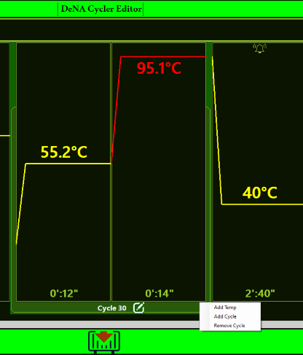

Figure 12. Configurable Settings in the Editor - Cycle Bar

It is worth mentioning that the user can define an incubation step. By clicking on the red tab in the bottom right corner of the software, one can define an incubation step. The incubation step only has a temperature variable, and its time is set to infinite by default.

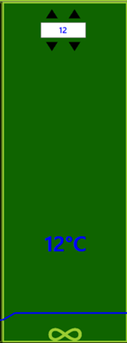

Figure 13. Incubation Step.

In this step, only the temperature is adjustable. The red tab on the left is for selecting the incubation step, and on the right is for configuring the incubation step.

Finally, after defining all the variables for a reaction, the user can save the file as a .DeNA file, with a final size of less than one kilobyte.

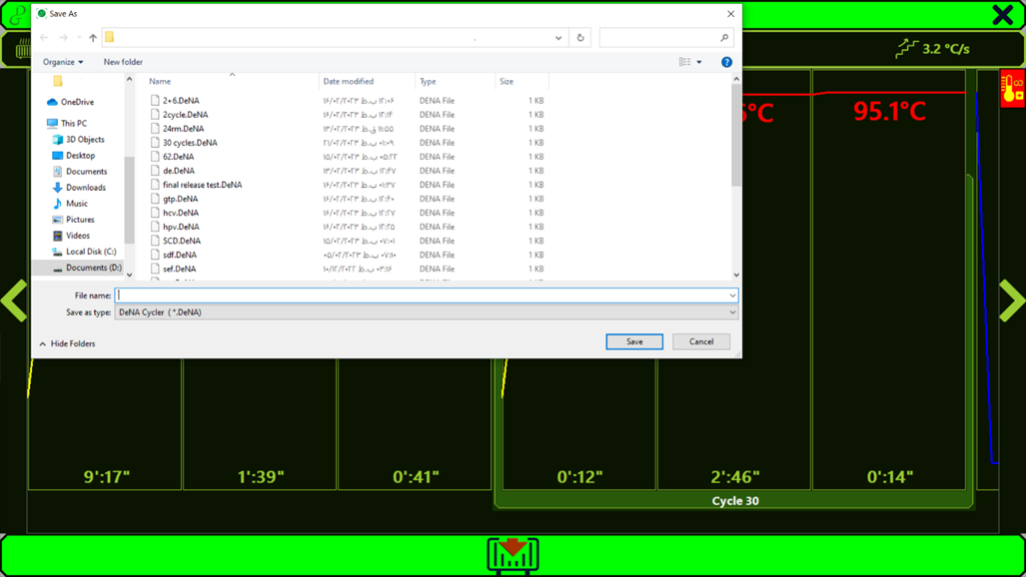

Figure 14. Saving a New Reaction.

To run the reaction, it is necessary to save it first.

However, if the user wants to run it directly, they need to first save the reaction, and ultimately run the reaction through the "Load to Thermo" tab at the bottom center of the page. If the software is connected to the device, it will enter the Running menu. However, if not connected, as shown in the figure below, the user will be prompted to connect to the device first before running the reaction.

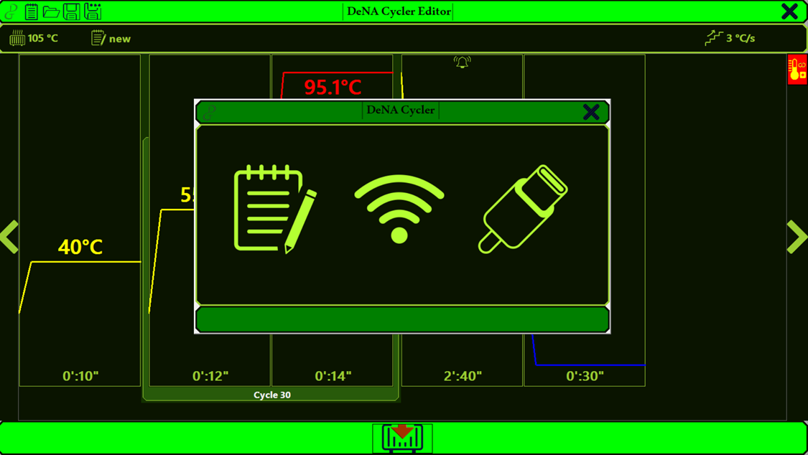

Figure 15. Running Command for the Reaction After Saving.

At this stage, to perform the reaction, if the software is connected to the USB port or Wi-Fi of the computer, it will directly enter the Running menu. However, if it is not connected, as shown in the figure above, the user will first be prompted to connect to the thermal cycler via USB or Wi-Fi, and then the running will take place.

A different step in defining thermal cycler reactions is the "touch step," where "touch down" is much more common compared to "touch up" and is often specifically used for annealing. Here, we provide an explanation of how the "touch down" works. In this step, the user defines the starting and ending temperatures, specifying how much temperature change should occur in each cycle until it reaches the desired annealing temperature after several cycles. In the lower section, there is also a tab for time step settings. As seen in the figure below, after defining the touch step for the number of cycles that need to undergo changes to keep the final annealing temperature constant, a graph line is created. After each cycle, one of the graph lines decreases until it ultimately reaches a single value.

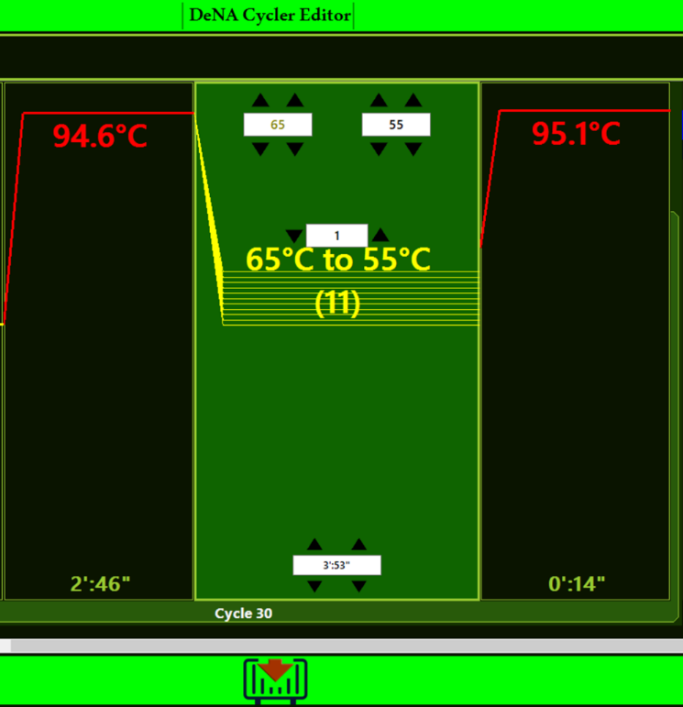

Figure 16. Touch Step Settings. The touch step can be either touch down or touch up.

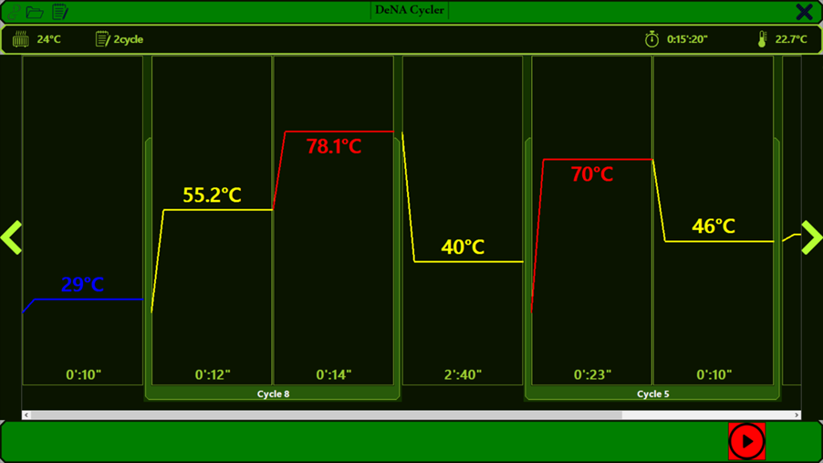

Figure 17. Running Menu of DeNA Cycler Software.

The running menu of the software has a dark green header, which can be easily distinguished from the editor menu at first glance due to the change in the header color. After running the reaction, it is necessary to go to the running menu and to execute the reaction, click on the red-colored "run reaction" tab at the bottom.

After loading the reaction into the thermal cycler, it is necessary to click on the "play" tab located in the bottom right corner of the software to initiate the reaction. Once the reaction is running, the temperature of the reaction in each step turns red, allowing the user to visually identify the progress of the reaction at each stage through this distinct color.

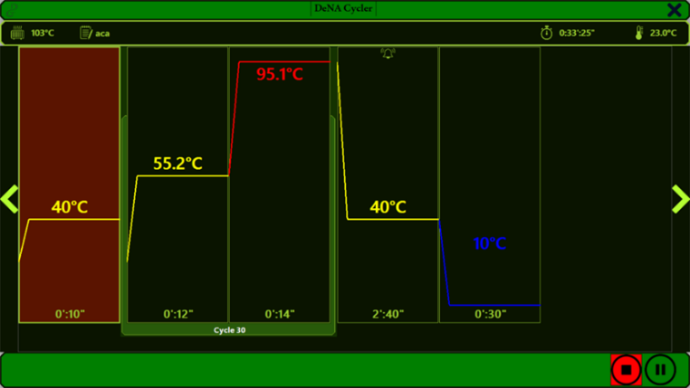

Figure 18. Changing the Color of the Step in the Reaction.

Essentially, by changing the color of this step, the user can easily discern which step the reaction is currently in.

During the reaction running, two buttons "play/stop" and "pause" appear at the bottom right of the reaction. Clicking on "stop" halts the reaction entirely, and clicking on "pause" creates a pause in the reaction. The user can resume running the reaction from the exact point where it was paused.

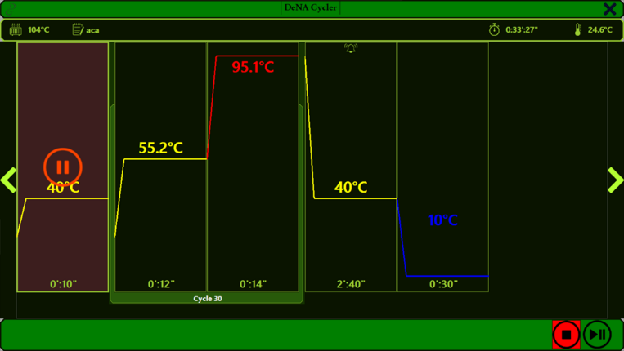

Figure 19. Pausing the Reaction.

When the reaction is paused, a pause icon appears on the step where the reaction has been halted.

**Important Notes:**

In the settings menu for each step, there are options for "alarm" and "alarm end." In "alarm," a set number of beeps occur, and it stops eventually. However, in "alarm end," the device starts beeping continuously and must be explicitly triggered to stop, typically at the end of the reaction. Therefore, it is strongly recommended to set "alarm end" only for the end of the reaction and avoid setting it for intermediate steps of the reaction.

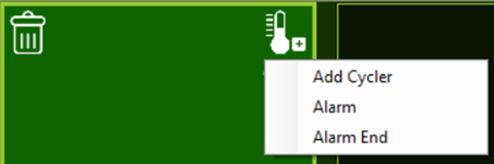

Figure 20. Alarm Definition Tab.

This tab is present for all steps. It is advisable to only set it for the last step as "Alarm End," and for other steps, use it only, if necessary, as "Alarm."

**Important notes:**

- The default heat lid temperature is set to 105 degrees Celsius, preventing liquids inside the reaction tube from evaporating. Evaporation could lead to the concentration of reaction components in the microtube, disrupting the defined reaction equilibrium. The heat lid temperature can be adjusted between room temperature and 110 degrees Celsius, but it is strongly recommended not to deviate from 105 degrees unless necessary for specific cases.

- Occasionally, users may realize a mistake in the middle of the reaction and need to pause it. Pressing the "pause" button halts the PCR reaction, and after performing the necessary actions, the user can resume the reaction from where it was paused.

- Due to the presence of high-quality heat lids, it is advised to avoid using oil to cover the reaction whenever possible.

- To have an appropriate decreasing and increasing ramp in the thermal cycler, proper air ventilation in the device is essential. If the airflow is blocked, the device may not achieve the desired ramp. When setting up the thermal cycler in a new location, it is crucial to assess the ventilation suitability by following these steps:

1. Turn on all devices nearby.

2. Turn on the thermal cycler and run a standard 30-minute protocol.

3. Check the temperature of the circulated air inside the device.

4. If the temperature is above 31 degrees Celsius, it indicates the entry of air with a higher temperature into the device. In such cases, the device location should be changed to a more suitable place.

- Keep the thermal cycler away from heat sources such as radiators and spotlights.

**Applications:**

In general, the PCR device has applications in three main areas: amplification and cloning, diagnostics, and quantification. PCR is less commonly used for quantification and has more specific applications in the following areas:

- Nucleic acid amplification

- DNA cloning

- Disease diagnosis

- Genotyping and polymorphism analysis

- Mutation creation

- cDNA library construction

- Sequence analysis

- Forensic medicine and crime investigation

Warranty and After-Sales Services:

- In case of any technical issues, contact Dena Gene Equipment only, and avoid seeking assistance from unauthorized personnel.

- The thermal cycler manufactured by Dena Gene Equipment comes with a one-year warranty.

- The thermal cycler from Dena Gene Equipment is backed by 10 years of after-sales services.

**Documentation and Support**

To obtain support for the latest services and support information for all locations, go to:

[www.Denagene.com](http://www.Denagene.com)

At the website, you can:

• Access worldwide telephone and fax numbers to contact Technical Support and Sales facilities

• Search through frequently asked questions (FAQs)

• Submit a question directly to Technical Support

• Search for user documents, application notes, formulations, handbooks, certificates of analysis, citations, and other product support documents

• Obtain information about customer training

• Download software updates and patches

Contact Us:

[info@denagene.com](mailto:info@denagene.com)‌