Denagene Tajhiz Company

Biotechnology Lab Equipment manufacturer and designer

Semi-Dry User Guide

( Semi-dry )

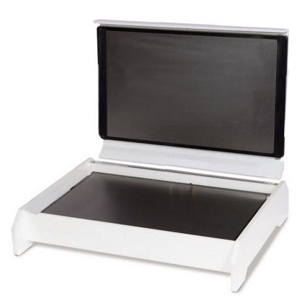

Thanks for choosing the Denagene Tajhiz Company’s Semi-Dry. This operation manual describes the function of the instrument. Please read the manual carefully before using it to ensure you can correctly operate the instrument. Please keep this manual properly for later use if you encounter any difficulty. The first time opening the packing, please check the instrument and appendix with the packing list. Don't hesitate to contact us if anything does not match the packing list.

This manual serves as a valuable resource for all users of our products, whether you are a seasoned professional or just starting your scientific journey. It has been meticulously crafted to ensure that you clearly understand our laboratory equipment's features, functionality, and proper usage.

Within these pages, you will find detailed instructions, diagrams, and troubleshooting guides that will assist you in harnessing the full potential of our products. We have taken great care to ensure that the content is organized logically, making it easy for you to navigate through the manual and locate the information you need quickly.

Moreover, this manual is a living document that reflects our ongoing commitment to excellence. As we continue to develop and improve our product offerings, we will provide updates and revisions to this manual to ensure that you always have the most up-to-date information at your fingertips.

Reproduction in any form, whether print or electronic, without written permission from Denagene Tajhiz Company, is strictly prohibited.

Content

Introduction

Safety Instructions

Technical Specifications

How to Transfer Protein in Semi-Dry

Semi-Dry Transfer in Continuous Buffer

Materials for the Experiment

Experimental Procedure

General staining of proteins on the membrane

Reversible Staining with Ponceau S

Reversible Staining with Amido Black

Irreversible Staining with Coomassie Blue

Irreversible Staining with Amido Black

Protein Marker Staining

Specific Protein Detection on Membrane

Western Blotting Technique

Blocking Step

Antibody Detection

Materials

Experimental Method

Troubleshooting Guide

Weak Transfer

Weak Binding to Nitrocellulose Membrane

Low Detection Sensitivity or Reactivity

**Introduction**

In blotting techniques, Southern blotting was first performed in 1975 by transferring DNA from agarose gel to nitrocellulose membrane. Subsequently, the blotting technique was applied to RNA and protein molecules from both agarose and polyacrylamide gels. PVDF membranes were also used to improve protein binding capacity. To enhance the quality of the capillary transfer, in 1979, Towbin and colleagues used an electric current to separate proteins from a polyacrylamide gel. Since then, electrophoretic transfer has been utilized for blotting techniques.

For the first time in 1984, Anderson introduced the semi-dry technique. Initially, blotting was performed horizontally using plate electrodes. The gel and nitrocellulose membrane were sandwiched between filter paper sheets soaked with buffer. The filter papers acted as ion reservoirs and buffer substitutes in the wet state. With its high simplicity, the semi-dry blotting system has maintained the basic principles of the semi-dry blotting technique and has introduced some new features, resulting in easy use and quick setup.

**Safety Instructions**

Before starting the blotting process, thoroughly read the device manual.

Do not change the polarity of the device.

Do not apply excessive voltage and current to the device, as this can reduce its lifespan.

Long transfer times for proteins are not recommended.

It is better to perform semi-dry transfer using the Denagene Tajhiz model DGT-Universal power supply. All settings and quality control have been conducted with this device.

Do not use this device at temperatures above 50 degrees Celsius.

Technical Specifications

|  |  |
| --- | --- |
| Model | SD- transblot |
| capacity | 1 gel |
| Maximum temperature | 50 °C |
| Maximum humidity | Up to 80% |
| Maximum gel size | 20 cm x 15 cm |
| Dimensions (Length × Width × Height) | 20 cm x 15 cm x 5 cm |

Table 1) Technical Specifications of the Semi-Dry Device

Protein Transfer Method in Semi-Dry Blotting

In this method for transferring proteins, a buffer tank is not required. The connection between the membrane and the gel is established through several layers of wet paper using flat electrodes. This is why the term "semi-dry" is applied to this method. Semi-dry transfer is generally simpler and faster than wet transfer methods and requires very little buffer. The limitation of buffer capacity in this method means that blotting cannot exceed 2 hours; otherwise, it is better to use tank transfer.

In semi-dry transfer, it is possible to blot 6 gels simultaneously. In this case, each gel sandwich is separated from the top or bottom sandwich by a dialysis membrane (cellophane). In this method, different gels cannot be stacked on top of each other for simultaneous blotting. When blotting occurs in a single gel, either a continuous or discontinuous buffer system can be used. The choice of suitable buffer depends on the nature of the protein, type of electrophoresis, type of membrane used, and characteristics of the gel.

**Semi-Dry Transfer in Continuous Buffer**

|  |  |  |  |
| --- | --- | --- | --- |
| Descriptions | PH | Components | Buffer name |
| The first buffer introduced for electroblotting. | 8,3 | Tris 25 mM, Glycine 192 mM, Methanol 20% (7/7). | Towbin buffer |
| SDS increases the negative charge and solubility of proteins, but it can interfere with the binding of proteins to the membrane. If necessary, lower concentrations can be used. | 8,3 | Tris 25 mM, Glycine 192 mM, Methanol 20% (7/7), SDS 0.05% (w/v). | Towbin buffer containing SDS |
| Transfers various proteins electrophoresed by SDS-PAGE and isoelectric focusing due to the presence of SDS and higher pH | 9.5 | 12.5 mM Tris, 96 mM Glycine, 10% (v/v) Methanol | Diluted Towbin Buffer |
| Has a higher pH than Towbin buffer and weaker ionic strength | 9.2 | 40 mM Tris, 39 mM Glycine, 20% (v/v) Methanol | Schafer-Nielsen Buffer |
| Can be used for the transfer of large glycoproteins | 8.3 | |  | | --- | | 25 mM Tris, 192 mM Glycine |  |  | | --- | |  | | Towbin Buffer without Methanol |
| Suitable for electroblotting aimed at determining amino acid sequences in proteins | 11 | 10 mM CAPS, 10% (v/v) Methanol | CAPS Buffer |

Table 2: Types of Continuous Buffers Used in Electroblotting

Continuous buffers used in semi-dry transfer are usually a combination of Tris-Glycine with different ionic strengths and pH values, which may contain very low concentrations of SDS depending on the experimental conditions. Some of these buffers are listed in the table below. These buffers can also be used in the semi-dry method.

**Materials Used for the Experiment**

1. Transfer Buffer: This buffer includes 12.5 mM Tris, 96 mM Glycine, 0.03% SDS, and 10% Methanol with a pH of 8.3. To prepare it, dissolve 1.5 grams of Tris base, 7.2 grams of Glycine, and 0.3 grams of SDS in approximately 800 ml of distilled water. Add 100 ml of Methanol and adjust the final volume to 1 liter with distilled water. The solution should be cool when used.

2. Nitrocellulose Membrane: With a pore size of 0.45 microns or PVDF.

3. Thick Whatman Paper or Electrophoresis Paper.

**Experiment Procedure**

1. Pour some transfer buffer into a clean container. After removing the top part (stacking gel) of the gel, place it in the buffer.

2. Cut 6 layers of filter paper and one layer of membrane to the size of the gel and soak them in the buffer container. If using PVDF membrane, soak it in pure methanol for a few moments before placing it in the buffer. Avoid contact of your hands with the blotting components and solutions.

3. Place the anode plate (with the red wire) in its designated position in the electrophoresis tank. First, place 2-3 layers of buffer-soaked paper on the anode. Then stack the remaining components as shown below. After placing each layer, use a pipette or a clean test tube as a roller to remove any air bubbles.

4. Place the cathode plate on top of the blotting assembly. Electrophorese for 1-2 hours at 20-30 volts.

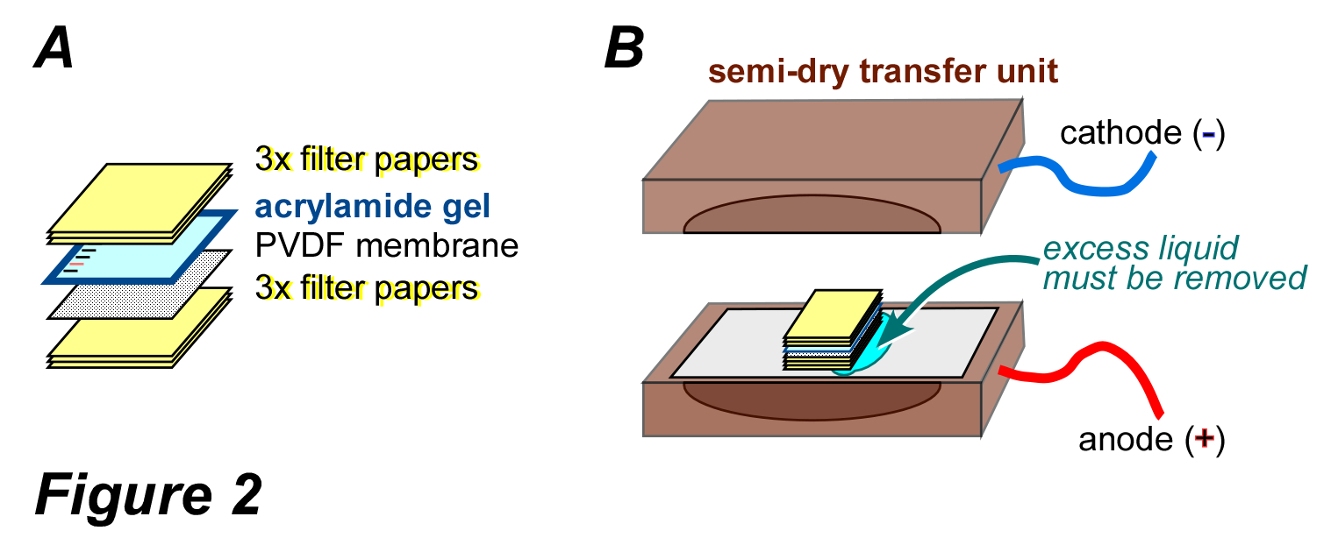

Figure 1) Transition layers in the Semi-Dry technique

**General staining of proteins on the membrane**

|  |  |  |
| --- | --- | --- |
| **Type of membrane** | Sensitivity (micrograms per band) | **Staining reagent** |
| Nitrocellulose ,PVDF | 1/5< | Fast Green FG |
| Nitrocellulose ,PVDF | 1/5< | Ponceau-S |
| PVDF | 1/5 | coomassie blue r-250 |
| Nitrocellulose ,PVDF | 1/5 | Amido Black 10B |
| Nitrocellulose ,PVDF | 0/1 | India Ink |
| Nitrocellulose, PVDF, and Nylon | 0/03 | Colloidal Iron |
| Nitrocellulose, PVDF,and Nylon | 0/03 | Biotin and Avidin-Peroxidase |
| Nitrocellulose ,PVDF | 0/004 | Colloidal Gold |

Table 3) Reagents used for general protein staining on membranes.

After blotting proteins, it is necessary to obtain information on the quality and quantity of the transferred bands or to identify a specific protein for further studies (e.g., sequencing). For this purpose, nitrocellulose or PVDF membranes can be stained with various reagents. Protein staining can be either reversible or irreversible, depending on the experimental goals. Common reagents for general protein staining on membranes include Ponceau S, India Ink, Amido Black, and Coomassie Blue. Staining the gel also indicates the completeness or incompleteness of protein transfer. Protein bands in the gel and membrane do not exactly align because the gel shrinks slightly during equilibration in the transfer buffer due to the presence of methanol.

**Reversible staining with Ponceau S**

The staining solution consists of 0.1% (w/v) Ponceau S in 5% (v/v) acetic acid. A ready-to-use solution is also available from various companies. To stain the membrane, immerse it in an adequate amount of the staining solution for 5-10 minutes. Then wash with distilled water until the background of the membrane is colorless.

Protein bands will appear red after staining. If washing with water continues, the bands will become colorless as well. Ponceau S staining does not interfere with band detection using specific methods (e.g., immunoblotting) or with amino acid sequencing. The sensitivity of this method is relatively low.

**Reversible staining with Amido Black**

The staining solution typically contains Amido Black 10B in a mixture of acetic acid and methanol. To stain the membrane, immerse it in the staining solution for a specified duration, usually 30 minutes to 1 hour. After staining, rinse the membrane with an acetic acid solution to remove excess dye and then with water to further reduce background staining.

Protein bands will appear black after staining. If the staining needs to be reversed, the membrane can be treated with a solution of methanol and acetic acid, which will decolorize the bands while leaving the background clear. Amido Black staining does not interfere with subsequent specific detection methods (e.g., immunoblotting) or amino acid sequencing. This method is relatively sensitive and provides a good contrast for visualizing protein bands.

**Irreversible staining with Coomassie Blue**

The staining solution contains 0.1% (w/v) Coomassie Blue R-250 in a mixture of 7% (v/v) acetic acid and 50% (v/v) methanol in distilled water.The destaining solution consists of 7% (v/v) acetic acid and 50% (v/v) methanol in distilled water. Gel staining with Coomassie Blue is also performed using these solutions.

Immerse the membrane in an adequate amount of the staining solution for 15 minutes. After staining, discard the staining solution and rinse the membrane in the destaining solution until the blue background becomes colorless. Then, wash the membrane with distilled water.

Coomassie Blue is suitable for staining proteins on PVDF membranes. Do not use this dye for nitrocellulose membranes as it will result in a heavily stained background.

**Irreversible staining with Coomassie Blue**

The staining solution contains 0.1% (w/v) Coomassie Blue R-250 in a mixture of 7% (v/v) acetic acid and 50% (v/v) methanol in distilled water.

The destaining solution consists of 7% (v/v) acetic acid and 50% (v/v) methanol in distilled water. Gel staining with Coomassie Blue is also carried out using these solutions.

Immerse the membrane in an adequate amount of the staining solution for 15 minutes. After staining, discard the staining solution and rinse the membrane in the destaining solution until the blue background becomes colorless. Then, wash the membrane with distilled water.

Coomassie Blue is suitable for staining proteins on PVDF membranes. Do not use this dye for nitrocellulose membranes as it will result in a heavily stained background.

**Irreversible staining with Amido Black**

The staining solution contains 0.5% (w/v) Amido Black, 5% (v/v) acetic acid, and 50% (v/v) methanol in distilled water.

The destaining solution consists of 5% (v/v) acetic acid and 50% (v/v) methanol in distilled water.

Place the membrane in the destaining solution for 5 minutes. Discard the staining solution and rinse the membrane with the destaining solution until the background turns blue.

**Staining Protein Markers**

Determining certain characteristics of proteins, such as size or isoelectric point (pI), is done using protein markers. To detect markers on a membrane, you can use the following methods:

1.Isolate the marker section from the rest of the membrane and stain it using one of the irreversible methods mentioned earlier (stain PVDF with Coomassie Blue and nitrocellulose with Amido Black). Then, dry this section of the membrane and place it alongside the other results.

2.Depending on the brand, the position and number of bands of the markers may vary.

3.You can prepare biotinylated markers or biotinylate the markers in the laboratory. In such cases, using avidin-peroxidase conjugates or avidin and anti-avidin-peroxidase conjugates allows you to determine the position of the markers.

4.Chicken albumin and bovine serum albumin are proteins commonly found in many types of markers. With antibodies against these proteins conjugated to an enzyme (or primary antibodies against them and secondary conjugated antibodies), you can determine their position on the membrane. This method is applicable if these proteins were not used as blocking agents in the membrane.

**Specific Protein Detection on Membrane**

Specific detection or staining of protein bands on membranes is based on their reaction with specific ligands. To perform this, ligand molecules are labeled directly (primary) or indirectly (secondary) with radioactive substances, fluorescence, dyes, or enzymes, and used for the specific detection of proteins. Antibodies are among the most commonly used specific ligands for various diagnostic and research purposes. The basis of the immunoblotting method, which is well-recognized by researchers in the biological sciences, supports this claim.

**Western Blotting Technique**

This method, also known as immunoblotting, is based on the primary antibody-antigen reaction. In this technique, after protein blotting, the membrane's free areas are first blocked (blocking step). Then, the antibody reaction conditions (such as patient serum) with protein bands are provided, followed by the use of labeled macromolecules (such as an enzyme-conjugated anti-human immunoglobulin antibody) to reveal the results of the primary reaction. Today, Western blotting is widely used in clinical diagnostics and research. Although the method follows a series of general principles, the conditions and details depend on the specific goals of the experiment.

**Blocking Step**

Membranes used in blotting have a high capacity for protein binding (for example, 100 micrograms per square centimeter of nitrocellulose membrane). While this property is advantageous, it can lead to non-specific binding of labeled proteins in subsequent steps of the experiment, causing interference in detection.

|  |  |
| --- | --- |
| **Description** | **Blocking reagent** |
| Tween-20 is used at a concentration of 2-5% in buffer (typically PBS) for 1-2 hours. For blocking nylon membranes, a concentration of 10% is required for 12-16 hours. | Bovine serum albumin |
| It is used at a concentration of 3%. It is very inexpensive and, due to its high sugar content, prevents the binding of lectins or anti-carbohydrate antibodies (as labeled molecules). | Non-Fat Dry Milk |
| It is used at a concentration of 1%. | Chicken Albumin |
| It is used at a concentration of 0.3-3%. Fish gelatin has more suitable properties than mammalian gelatin as a blocking reagent. | Gelatin |
| A concentration between 0.1-0.5% is sufficient. It is easy to use and cost-effective. It also prevents non-specific protein interactions. | TWEEN 20 Detergent |

# 

# Table 4) Types of Blocking Reagents Used in Blotting

# Therefore, the free areas of the membrane must be blocked before the detection stages. The best method for blocking these free areas is to use proteins that do not react with labeled substances (such as antibodies) themselves. Cost-effectiveness and ease of preparation are key criteria for selecting blocking proteins. The table below lists the names and working concentrations of several blocking proteins. Detergents can also prevent protein binding to the membrane. Tween 20 is the most commonly used detergent for this purpose. It should be noted that Tween 20, at high concentrations (over 0.5%), can sometimes prevent the binding of ligands to proteins

# Detection with Antibodies

# After blotting proteins and blocking the membrane, the specific detection step can be carried out. As mentioned earlier, immunoblotting is often used for diagnostic purposes. In these cases, the transferred bands include all or part of the proteins from the microorganism (bacteria, virus, or fungus), and the presence or absence of antibodies against them in human or animal serum is investigated. Detection using antibodies, similar to the ELISA technique, can be performed in two ways: direct and indirect.

# In the direct method, the primary antibody used to detect the antigen is labeled with an enzyme or fluorescent dye.

# In the indirect method, a primary antibody is first added to bind to the antigen. Then, a secondary antibody, which is labeled, is added. Biotin is used for binding, and fluorescent probes such as fluorescein or rhodamine, and enzyme conjugates like HRP (horseradish peroxidase) or alkaline phosphatase, are used for detection and signal generation.

# The following figure illustrates the basic principles of these two types of immunoblotting techniques.

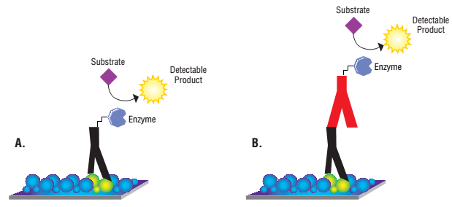

Figure 2) Various Methods of Detection Using Antibodies. In Panel A, the target protein is detected directly. In Panel B, the target molecule is detected indirectly.

**Materials**

1. Tris-Buffered Saline (TBS) with pH 7.5: This buffer contains 20 mM Tris and 0.15 M sodium chloride.

2. Tris-Buffered Saline with Tween 0.05% (TBS-T): Add 0.5 mL of Tween-20 to each liter of TBS.

3. Primary Antibody (patient or immunized animal serum): Dilute with TBS-T if necessary.

4. Secondary Antibody: This antibody targets the constant region of the primary antibody and is conjugated with an enzyme (peroxidase). The required dilution of this antibody is prepared in TBS-T.

5.Peroxidase Substrate Solution: Contains 0.5 mg/mL diaminobenzidine (DAB) and 0.1% hydrogen peroxide in TBS.

**Procedure**

1. After blocking, wash the membrane three times with TBS-T, 5 minutes each time. Then, incubate the membrane with the primary antibody for 1-2 hours.

2. Wash the membrane four times with TBS-T, 5 minutes each time. Then, incubate the membrane with the secondary antibody (conjugated with peroxidase) for 1-2 hours.

3. Wash the membrane four times with TBS-T, 5 minutes each time. Then, expose it to a sufficient amount of the substrate solution. Band development usually takes 5-15 minutes. After bands appear, wash the membrane thoroughly with distilled water. Dry the membrane and place it in a dark place.

Note: Diaminobenzidine (DAB) is highly toxic. Avoid contact with it and handle it with care.

|  |  |
| --- | --- |
|  | Transfer |
| Blocking Unbound Areas on the Membrane |
| Incubation with Primary Antibody |
| Washing |
| Incubation with Conjugated Secondary Antibody or Ligand |
| Washing |
| Signal Generation Based on Color or Luminescence |
| Visualization and Imaging with Gel Documentation and Result Analysis |

Table 5) General Steps of the Western Blot Process

**Troubleshooting Guide**

Weak Transfer:

Short Transfer Time: Increase the transfer time.

Incorrect Ratio of Load to Mass: Proteins near their isoelectric point in the buffer pH have poor transfer. Use a buffer with stronger acidic or alkaline properties to improve protein transfer.

Dry Blotting Paper: Ensure the blotting paper is thoroughly soaked in buffer before the transfer. Increase the number of blotting paper sheets or use thicker blotting paper.

Power Supply Issues: Check the fuses.

High Gel Percentage: Reduce the amount of monomers (T) or cross-linkers (C). Reducing C below 5% will increase pore size and improve transfer quality.

Methanol in Buffer: Methanol limits protein washing from the gel. Removing methanol improves transfer quality but may reduce binding to nitrocellulose. Use PVDF instead.

Protein Precipitation in Gel:Try using SDS in the transfer buffer to improve transfer quality, though it might reduce binding to nitrocellulose and affect antibody reactivity.

Poor Contact Between Blot Membrane and Gel: Air bubbles or excess moisture between the blot and gel can occur. Use a pipette to carefully roll the membrane on the blotting paper in two directions to remove excess moisture and air bubbles, ensuring complete contact. Use thicker blotting paper in the gel/membrane sandwich and ensure no air bubbles are present.

Gel Not Fully Equilibrated in Transfer Buffer: Ensure the gel is fully equilibrated in transfer buffer to prevent wrinkling or swelling during transfer. Increase washing time or frequency.

Cross-Contamination with Multiple Gels: Use a dialysis bag with smaller pores to separate gel/membrane sandwiches or use PVDF for higher quality binding in smaller pieces.

High Applied Power: Reduce the voltage and check the buffer conductivity. Improperly prepared buffer can cause excessive power application to the transfer system.

**Weak Binding to Nitrocellulose Membrane**

Methanol Concentration: Proteins separated by SDS-PAGE require 20% methanol for optimal transfer conditions. Ensure the buffer contains sufficient methanol.

Protein Size: Proteins larger than 15 kDa may bind poorly to 0.45 µm nitrocellulose membranes or may be washed off during the assay. Use 0.2 µm nitrocellulose membranes for better binding. Proteins can be cross-linked with glutaraldehyde to improve binding.

Detergent Effects: Proteins can be removed from nitrocellulose membranes by SDS, NP-40, and other detergents. Use Tween 20 during washing and antibody incubation steps. Either remove detergents from the buffer or reduce their concentration. Consider using glutaraldehyde fixation.

SDS in Transfer Buffers: SDS in transfer buffers can reduce protein binding quality. Use 20% methanol in the transfer buffer and equilibrate the gel in methanol buffer before transfer.

**Low Sensitivity or Poor Reactivity**

Check Kit Instructions: Ensure adherence to the guidelines provided with the kit.

Antigen Binding:Verify if antigen binding is incomplete.

Insufficient Incubation Times: Increase the incubation times for antibodies.

Sample Loading: Increase the concentration of protein loaded onto the gel.

Temperature Settings: Antigens may require specific temperature conditions to prevent denaturation during transfer. Use transfer devices equipped with a circulator.

Monoclonal Antibodies: Monoclonal antibodies may not recognize denatured antigens. Check alternative monoclonal or polyclonal antibodies. Perform blotting with native proteins.

**Documentation and Support**

To obtain support for the latest services and support information for all locations, go to:

[www.Denagene.com](http://www.Denagene.com)

At the website, you can:

• Access worldwide telephone and fax numbers to contact Technical Support and Sales facilities

• Search through frequently asked questions (FAQs)

• Submit a question directly to Technical Support

• Search for user documents, application notes, formulations, handbooks, certificates of analysis, citations, and other product support documents

• Obtain information about customer training

• Download software updates and patches

Contact Us:

[info@denagene.com](mailto:info@denagene.com)‌