`

**Denagene Tajhiz Company**

**Biotechnology Lab Equipment manufacturer and designer**

Gel Documentation

USER GUIDE

Gel Documentation

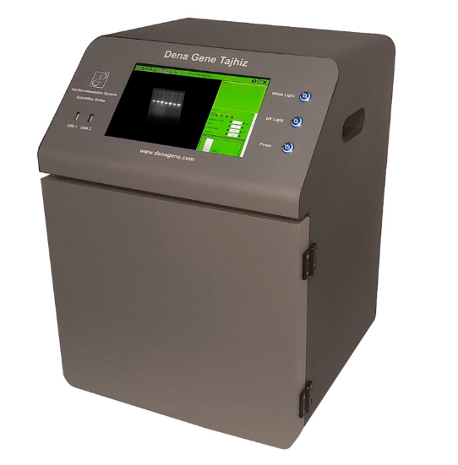

Thanks for choosing The Denagene Tajhiz Company’s Gel Documentation. This operation manual describes the function of the instrument. Please read the manual carefully before using it to ensure you can correctly operate the instrument. Please keep this manual properly for later use if you encounter any difficulty. The first time opening the packing, please check the instrument and appendix with the packing list. If anything does not match the packing list, don't hesitate to get in touch with us.

This manual serves as a valuable resource for all users of our products, whether you are a seasoned professional or just starting your scientific journey. It has been meticulously crafted to ensure that you clearly understand the features, functionality, and proper usage of our laboratory equipment.

Within these pages, you will find detailed instructions, diagrams, and troubleshooting guides that will assist you in harnessing the full potential of our products. We have taken great care to ensure that the content is organized logically, making it easy for you to navigate through the manual and locate the information you need quickly.

Moreover, this manual is a living document that reflects our ongoing commitment to excellence. As we continue to develop and improve our product offerings, we will provide updates and revisions to this manual to ensure that you always have the most up-to-date information at your fingertips.

Reproduction in any form, whether print or electronic, without written permission from Denagene Tajhiz Company, is strictly prohibited.

Content

Introduction

Product Description

Warning

Set Up and Installation

DGIS software

Transilluminator mode

Safety information

Technical Description

Features

Applications

Warranty and Technical support

**Introduction**

Gel Doc is an abbreviation for Gel Documentation and is commonly used among specialists in this field. The operation of a Gel Doc apparatus involves the transmission of UV light through a transilluminator onto the gel, exciting the electron atoms of the Ethidium bromide (EB) and generating visible light. Subsequently, a Scientific imaging camera is used to document the process. Gel Docs are typically used in laboratories for the analysis of DNA and RNA. Gel Docs have advanced software that automatically collects, analyzes, and validates data. Cellular and molecular biology laboratories that study nucleic acids and proteins require gel documentation and imaging systems.

**Gel Documentation**

After completing the electrophoresis process, it is necessary to examine the results related to DNA bands. The best and safest way to analyze the results of the gel electrophoresis process is to use Gel Documentation. The Gel Documentation device consists of a transilluminator system, an imaging system, and a hood. In the Endpoint visualization process (as opposed to Real-time visualization), it is necessary to place the amplified amplicons on the gel and eventually observe them by using a fluorescent dye attached to the DNA, activated by a wavelength corresponding to its absorption peak. In fact, during the electrophoresis process, DNA is usually stained with an external fluorescent dye that is activated by a specific wavelength. Therefore, considering the excitation wavelength of the dye used in the electrophoresis process, one can choose the desired Gel Documentation device and imaging system. To meet the needs of researchers, Denagene Tajhiz Company has designed and produced various models of Gel Documentation with different designs and wavelengths. In all Gel Documentation apparatuses manufactured by Denagene, high-quality Scientific cameras with CMOS sensors for excellent gel imaging are used. Additionally, a notable feature that distinguishes this device from older imaging systems is the use of a computer and an LCD Touch screen on the device itself, which is particularly useful for small laboratory spaces. In terms of safety, all models of Gel Documentation apparatus use a fully UV-safe cover.

**Warning:**

• Due to the hazards associated with UV light, a sensor is installed on the device's door. If the door is open, the transilluminator of the device will not turn on under any circumstances. This warning is to inform the user that only when the device is closed, the user is safe from UV light exposure and can use the device.

• When using dyes for DNA staining, it is important to note that all dyes, especially Ethidium bromide, have carcinogenic properties. Therefore, maximum safety precautions should be taken regarding these dyes.

• Note: Denagene Tajhiz Company produces a type of dye called Safe Stain, which has sensitivity similar to Ethidium bromide but is not carcinogenic according to Ames-test results.

• In case of any issues with the device, please inform the personnel of Denagene Company immediately without attempting any curious actions to repair the device.

**Instructions for Use:**

The usage of this device is incredibly simple. After completing the gel electrophoresis process, place the gel on the viewing area of the transilluminator. Next, turn on the power switch located at the back of the device. Now, if the user only wants to use the transilluminator, set it to the "Tr" mode. After setting the transilluminator to the "Tr" mode, place the gel on its surface and place the UV shield on top of the transilluminator. Then, depending on the type of dye used, the user selects either the 254 nm or 312 nm wavelength.

However, if the user wants to capture and record images through gel documentation, they should set the transilluminator to the "G.D." mode. Place the gel on the transilluminator, and there is no need to place the UV shield on top. The user selects their desired wavelength from the transilluminator panel and closes the device's door.

Now, turn on the power switch located on the device panel to activate the gel documentation system. All settings related to the DC power system are built into the device itself, so the user does not need to purchase a separate power supply or adapter. The user can directly connect the device to the main power and turn it on for use.

Essentially, the computer system and gel documentation imaging system turn on when the power switch of the device is pressed. The Windows operating system makes it more user-friendly.

In the next step, after the operating system of the device has booted up, the user turns on the White Light button to assess the gel's positioning suitability and examines the gel's position. Once the appropriate gel positioning is confirmed, the user can turn on the UV Light button for imaging. Due to the harmful nature of UV radiation, the transilluminator of the device will only turn on when the gel documentation door is closed.

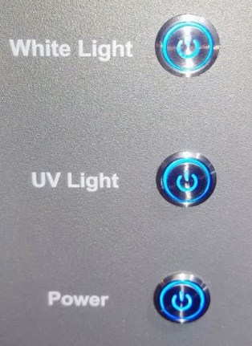

Figure 1. Gel Documentation Panel Buttons. Note that the illumination of the button lights does not indicate that the corresponding option is activated. The user must press the respective button downward to enable the desired function.

Now, by clicking on the DGIS software, open the software and adjust the relevant settings based on the band intensity and gel quality. After performing the necessary settings, which are comprehensively explained in a tutorial video, the bands will be visible through the device's monitor. The device can be operated in a way that provides the best image quality by utilizing the zoom and intensity features. After observing the bands, it is better to turn off the device as soon as possible due to the potential DNA damage from UV radiation. The images are stored on the device's memory and can be easily transferred to a USB flash drive for secondary processing using the USB ports embedded in the device. The Denagene Tajhiz Company Imaging Software (DGIS) is used for gel imaging purposes.

**DGIS Software**

After turning on the device, if the device's door is closed, its transilluminator is turned on, and the ability to view the bands is provided.

One important point for the user to consider is that the DGIS software is updated annually, and to better visualize the results of the gel documentation, it is necessary to update it.

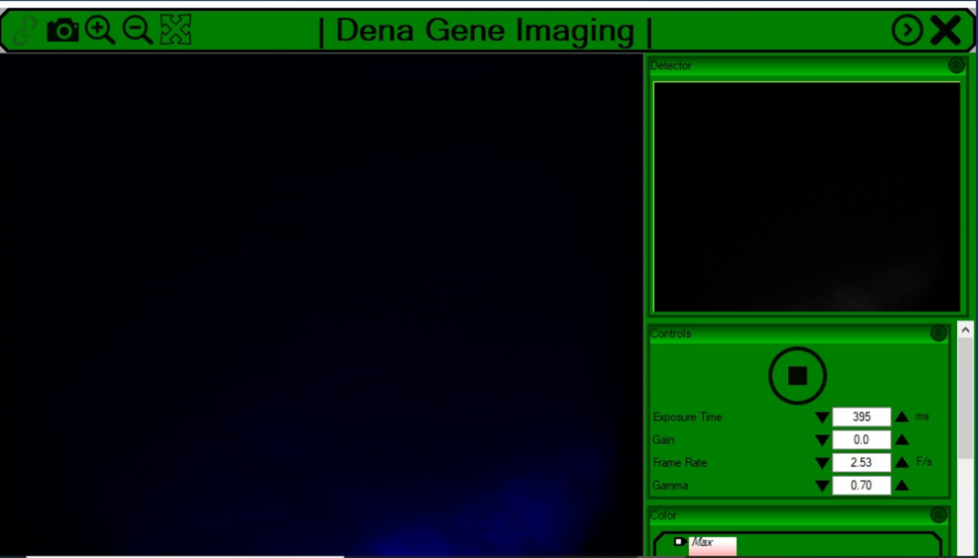

Figure 2. DGIS Software

The above figure represents an overview of the gel documentation imaging software, which is the DGIS software. By opening the software on the device, the simplicity of the design allows the user to easily perform the main imaging operations.

In the Settings menu, there are items such as exposure time, gain control, gamma, and frame rate related to lighting, as well as a series of adjustable color filters to create an image with the desired intensity and color. The user utilizes these settings to obtain an optimal image for their specific needs. By default, the numbers related to the settings are in a typical mode. Each band has its specific conditions depending on the intensity and background lighting, requiring customized adjustments of the imaging factors.

In previous versions, to capture an image, it was necessary for the user to first click on the Live View button to view the image in real-time. However, now, after opening the DGIS software, it automatically displays the live view, allowing the user to proceed with image capture. The user can click on their desired area and use the menu for a more precise selection of the desired region. Once the user sees the desired image, they can click on the Image Capture option to take the desired image. After capturing the image, the user can save it with their preferred file extension and in the designated location.

Exposure time: The longer the sensor is exposed to light, the lighter it will gather. In the figure below, the Exposure level has increased from left to right. Each sensor has its minimum and maximum thresholds, and the user cannot define values outside of that range.

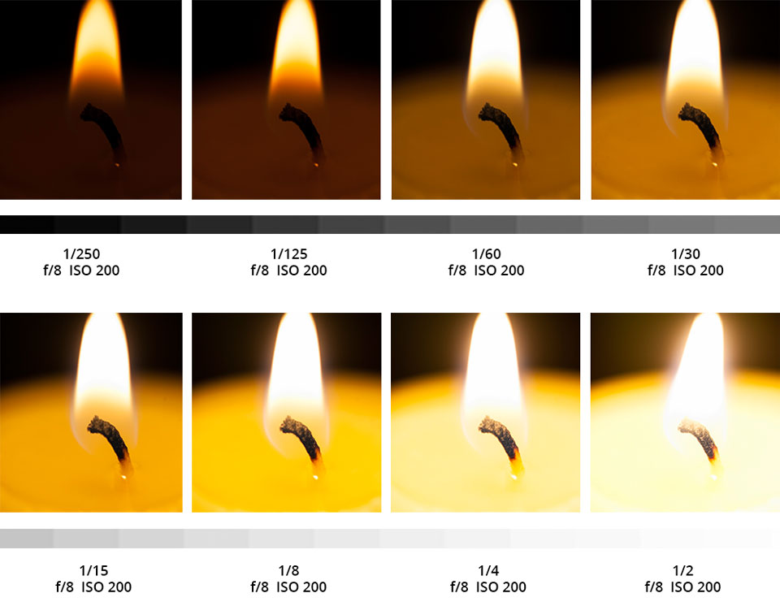

Figure 3. Different Exposure Times

Gamma: Gamma coefficients greater than 1 make the image darker, while coefficients less than 1 make the image brighter. Each sensor has its minimum and maximum thresholds, and the user should not define values outside of that range.

Gain: The gain coefficient uniformly amplifies both the signal and the noise in both modes. Each sensor has its minimum and maximum thresholds, and the user should not define values outside of that range.

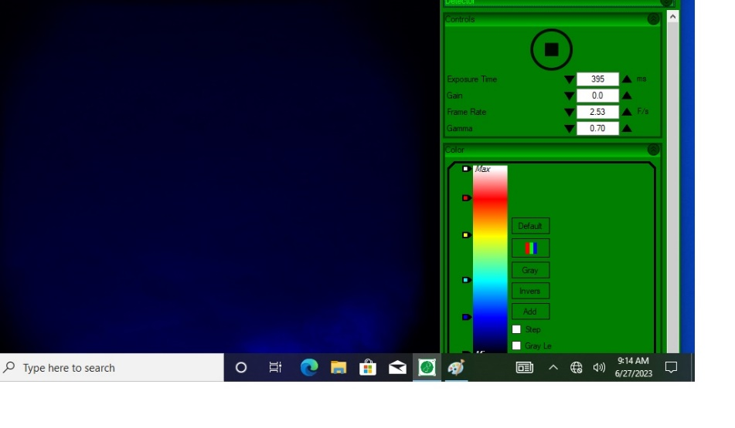

Figure 4. Imaging Detector Control Menu

**Transilluminator Mode:**

In normal mode, the transilluminator is set up for gel documentation mode. The power button on the apparatus is set to the G.D. mode. However, to use the transilluminator mode separately, it is necessary to first place the UV shield specific to the transilluminator on it and set the transilluminator power switch to the Tr. mode. The device's electronics are designed in a way that allows the user to use the transilluminator mode if needed.

**Important Points:**

• It should be noted that if the gel is placed on the device along with the tray, the user will not be able to see any bands. This is due to the UV-blocking property of the gel tray material. However, if the user selects the Scientifica Safe gel documentation model, this issue will not arise.

• It is important to consider that the maximum duration of the device being turned on should not exceed 10 minutes. By observing this point, the lifespan of the apparatus will be significantly extended.

• The user should select the appropriate gel documentation based on the type of routine dye used in the laboratory, considering its excitation wavelength, as well as the size of the prepared gel for electrophoresis. For example, the DNA dye produced by Denagene Tajhiz can be used with all wavelengths of 254, 312, and 470 nanometers in the gel documentation apparatus.

• By default, the apparatus is equipped with filters for safe stain and SYBER Green, which have been carefully calibrated to provide excellent intensity and visibility through the software. If the user has set up a specific dye in their laboratory, it is necessary to coordinate with Denagene Tajhiz Company before finalizing the purchase of the Gel Documentation system.

• It should be noted that, as mentioned earlier, Denagene Tajhiz Company is a manufacturer of a type of Safe gel stain that is fully compatible with gel documentation and provides excellent quality results.

• To better utilize the gel documentation apparatus, the company provides an instructional video for using the DGIS software.

• Typically, the most important parameter in the software for high-quality gel visualization is the exposure time of the apparatus. If the intensity of the DNA band color is strong, it is necessary to decrease the exposure time (the time the imaging system sensor needs to be exposed to light to reach saturation). Conversely, if the intensity of the DNA band color is weak, the exposure time needs to be increased to achieve a good-quality image.

• If the user wants to use only the transilluminator mode of the apparatus, it is essential to place the portable UV protective shield on it. The most sensitive parts of the body to UV light are the eyes, and even brief exposure to this light can cause significant damage. Therefore, it is crucial to take precautions and use the UV protective shield.

• The company includes a pre-set dye with every purchased apparatus, allowing users to perform their initial setup with minimal effort.

**Technical Specification**

|  |  |
| --- | --- |
| Scientifica Series | Model |
| 254 & 312 | Wavelength (nm) |
| 20 x 20 | Filter Size(cm) |
| High-Resolution Scientific Camera | Detector |
| Dena Gene Imaging Software (DGIS) | Imaging Software |
| 6 megapixels | Image Quality |
| 3.75x3.75µm | Pixel Size (Micrometer) |
| Ethidium or SYBR optionally chosen | Filter Dye |
| 10x30x36 | Transilluminator Dimensions |
| 70x45x40 | Transilluminator Dimensions Device |
| 24 | Weight (Kg) |

**Gel Documentation Features**

* Uniform Illumination Intensity Across the Filter’s Length
* Touchscreen Monitor with No Need to be Controlled by an External Computer
* External Memory Connectivity Capability
* Main Door Control of the Gel Documentation Device with a Sensitive Micro Switch
* Specialized Imaging Software with a Professional and User-Friendly Interface
* Ability to Use the Transilluminator Device Separately and Outside the Gel Documentation Circuit
* Scientific Imaging Capabilities
* Ability to Customize at Various Wavelengths
* Secure Design

**Applications of Gel Documentation:**

* Monoclonal and Polyclonal Antibody Binding Affinities
* Gel and Blot Imaging
* Colony Counting
* Immunoassay
* Multiplex Protein Detection
* Post-Translational Modification Characterization
* 2D Electrophoresis
* Protein Quantitation

**Warranty and Technical support**

• A one-year warranty covers the gel documentation apparatus manufactured by Denagene Tajhiz Company.

• Consumable items and lamps are not typically covered under warranty.

• The gel documentation apparatus manufactured by Denagene Tajhiz Company comes with 10 years of after-sales service.

**Documentation and Support**

To obtain support for the latest services and support information for all locations, go to:

[www.Denagene.com](http://www.Denagene.com)

At the website, you can:

• Access worldwide telephone and fax numbers to contact Technical Support and Sales facilities

• Search through frequently asked questions (FAQs)

• Submit a question directly to Technical Support

• Search for user documents, application notes, formulations, handbooks, certificates of analysis, citations, and other product support documents

• Obtain information about customer training

• Download software updates and patches

Contact Us:

[info@denagene.com](mailto:info@denagene.com)