**Denagene Tajhiz Company**

**Biotechnology Lab Equipment manufacturer and designer**

**Thermal Cycler**

**User Guide**

Thermal Cycler

User Guide

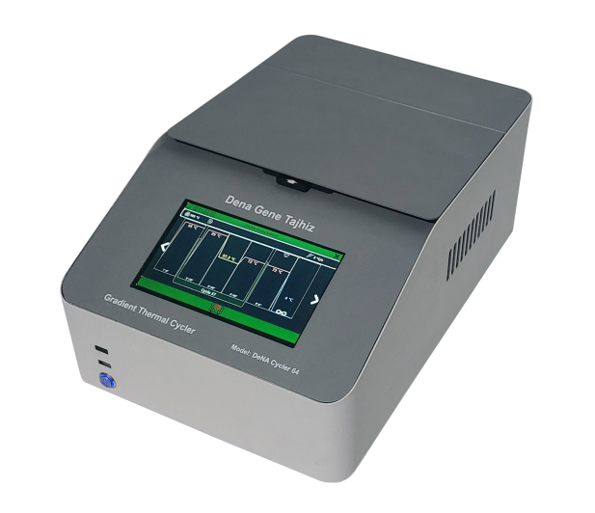

Thanks for choosing the Denagene Tajhiz’s company Thermal Cycler. This operation manual describes the function of the instrument. Please read the manual carefully before using it to ensure you can correctly operate the instrument. Please keep this manual properly for later use if you encounter any difficulty. The first time opening the packing, please check the instrument and appendix with the packing list. If anything does not match the packing list, don't hesitate to contact us.

This manual serves as a valuable resource for all users of our products, whether you are a seasoned professional or just starting your scientific journey. It has been meticulously crafted to ensure that you clearly understand our laboratory equipment's features, functionality, and proper usage.

Within these pages, you will find detailed instructions, diagrams, and troubleshooting guides that will assist you in harnessing the full potential of our products. We have taken great care to ensure that the content is organized logically, making it easy for you to navigate through the manual and locate the information you need quickly.

Moreover, this manual is a living document that reflects our ongoing commitment to excellence. As we continue to develop and improve our product offerings, we will provide updates and revisions to this manual to ensure that you always have the most up-to-date information at your fingertips.

Reproduction in any form, whether print or electronic, without written permission from Denagene Tajhiz Company, is strictly prohibited.

Contents

Introduction

PCR Technique

PCR Conditions

Thermal Cycler Device

Installation and Setup

General Overview of the PCR Device

Technical Specifications

How to Use

Touch Step

Gradient Step

Shutdown Procedure

Important Notes

Applications

Warranty and After-Sales Service

Introduction

To study molecular processes within cells, the most critical approach is to examine nucleic acids. Typically, the entire process of DNA replication occurs at 37°C within the cell. This is due to the complex replication mechanisms in living organisms, which involve numerous components. However, outside the cell, it is nearly impossible to replicate these conditions due to the multitude of variables, and even if it were possible, it would be extremely costly.

Moreover, given the small initial quantities of nucleic acids, they need to be amplified to a sufficient level for analysis and use. To address this, researchers discovered a type of thermo-stable DNA polymerase enzyme capable of withstanding and remaining active at high temperatures. Additionally, it was previously known that the double-stranded DNA structure is held together by hydrogen bonds, which can be disrupted by increasing the temperature, leading to the "melting" of the DNA strands. The process of melting the DNA and then cooling it again, in the presence of short oligonucleotides known as primers, allows for the replication of specific DNA regions. This DNA amplification process, facilitated by temperature fluctuations, is known as Polymerase Chain Reaction (PCR).

During the PCR process, the amount of nucleic acid is amplified to a sufficient level. This process requires the presence of a DNA template, primers, DNA polymerase enzyme, a master mix, and thermal cycles. These thermal cycles are necessary for denaturation, annealing, and extension at the optimal temperature for DNA polymerase activity. To perform these thermal cycles, a device known as a thermal cycler is required. The thermal cycler or PCR machine uses Peltier technology to efficiently carry out this process. By amplifying DNA, subsequent downstream processes such as diagnosis, cloning, genotyping, and sequencing can be easily performed.

Thermal cyclers come in both standard and gradient models, and Denagene has produced both types. This guide focuses on the gradient thermal cyclers from the DeNA Cycler series, specifically the DeNA Cycler 64 and DeNA Cycler 32 models.

**PCR Technique**

PCR (Polymerase Chain Reaction) is a technique used to amplify DNA outside the body of a living organism, but the goal is not to replicate the entire DNA sequence. Instead, the objective is to produce millions of copies of a specific gene of interest. Essentially, PCR is a form of replication that occurs outside the cell in an in vitro environment. The difference between PCR and natural cellular replication is that PCR occurs outside the cellular environment and is selective, targeting only a specific DNA sequence for amplification. In contrast, cellular replication duplicates the entire genome.

**Applications of PCR include:**

- Generating multiple copies of a specific gene

- Prenatal diagnosis of genetic diseases

- Investigating the presence or absence of a particular gene in a cell

- Determining the sex of a fetus

- Archaeological studies

- DNA sequencing

- Detecting chromosomal abnormalities

- Genetic fingerprinting

- Disease diagnosis: PCR can be used to diagnose a wide range of genetic diseases, including mutations, cancers, hemophilia, AIDS, sickle cell anemia, cystic fibrosis, thalassemia, tuberculosis, Duchenne muscular dystrophy, favism, phenylketonuria, and more. The sensitivity of PCR is 10,000 times greater than conventional methods. Evolutionary studies of organisms, etc.

**PCR Conditions**

For DNA amplification to occur, the double-stranded DNA must be separated so that primers can bind to the correct locations and initiate replication. In the cell, this process is facilitated by the enzyme helicase. However, in PCR, helicase is not required because the hydrogen bonds between the DNA strands are broken when the temperature is raised to 95°C, causing the strands to separate—a process known as DNA melting. In PCR, this step of separating the double-stranded DNA is called Denaturation (Figure 1).

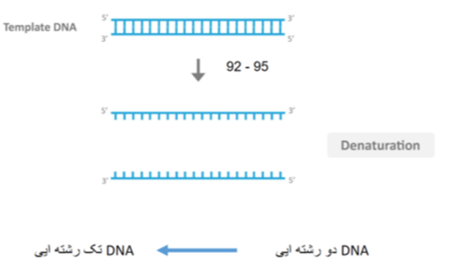

Figure 1. Denaturation Stage of DNA Strands

The Annealing Temperature is the temperature at which primers bind to the template sequence. When primers attach to the target sequence, they create a 3'-OH end, allowing DNA polymerase to add nucleotides to this end (Figure 2).

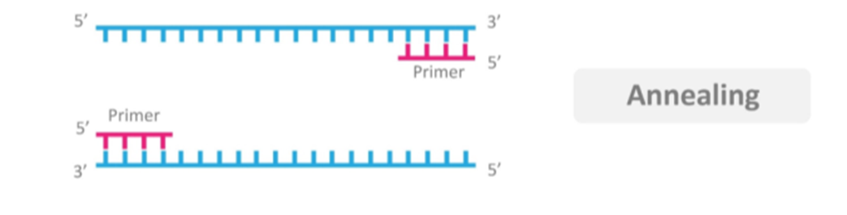

Figure 2. Annealing Stage of DNA Molecules

After the primers have bound to their specific sites, amplification must occur. This step in PCR is known as the Extension stage. During this phase, the temperature is raised to 72°C, which is optimal for DNA polymerase to achieve its highest efficiency and speed of replication. There is no need to remove the primers, as they are made of DNA (Figure 3). This stage has a specific duration, which is determined by the length of the target segment. Typically, the time required for this step is one minute per 1000 base pairs (bp).

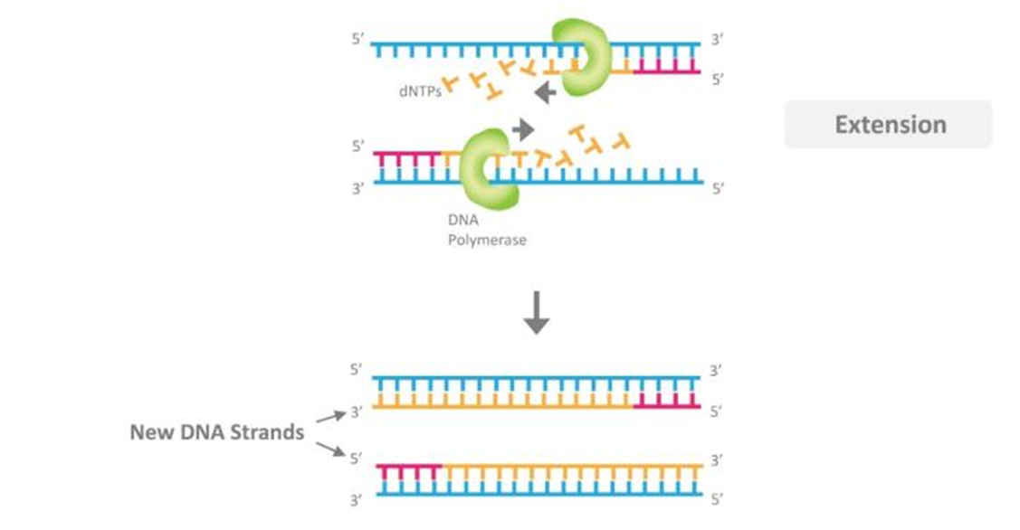

Figure 3. DNA Amplification Stage

The main stages of a PCR reaction are summarized as follows:

1. First Stage: Denaturation

- Separation of the DNA double strands at 94-95°C for 30-60 seconds

- Increasing the duration of this stage does not benefit the reaction except for reducing the activity and half-life of the Taq enzyme.

2. Second Stage: Annealing

- Binding of the primers to complementary regions on the DNA, defining the range of DNA fragment amplification at 40-60°C

- A duration of 30-60 seconds is suitable and sufficient for each primer pair.

3. Third Stage: Extension

- Amplification of the DNA fragment of interest at 72°C for 5 to 15 minutes

- For amplifying a 1 kb fragment, 1 minute is typically sufficient.

These three stages are repeated 25 to 35 times, which is referred to as PCR cycles. After 35 cycles, the number of amplified fragments reaches 68 billion copies (Figure 4).

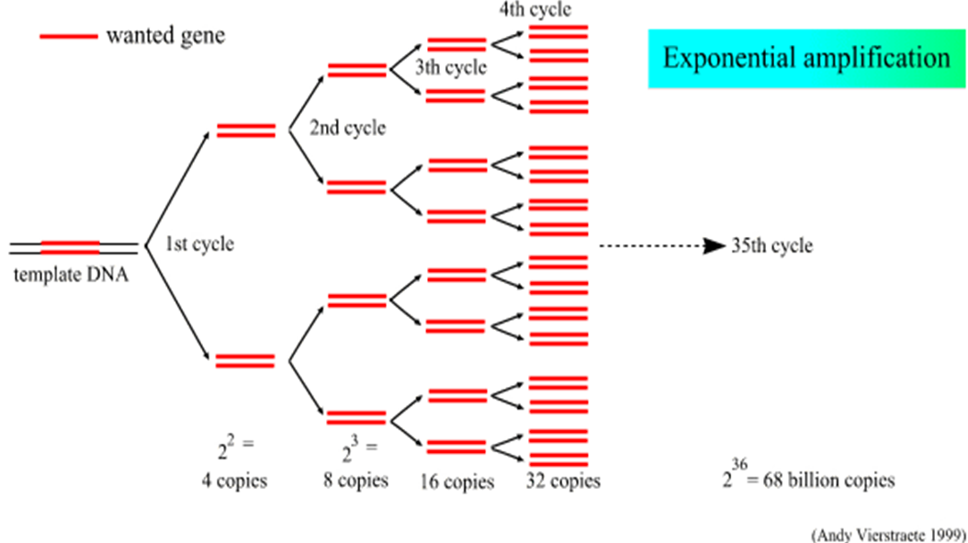

Figure 4. Exponential Amplification of DNA Molecules

**Thermal Cycler**

To study molecular processes within cells, examining nucleic acids is crucial. Given the small initial amounts of nucleic acids, it is necessary to amplify them to a sufficient level for analysis. Polymerase Chain Reaction (PCR) is a method used to achieve this amplification. During PCR, nucleic acids are sufficiently amplified using template DNA, primers, Taq polymerase enzyme, master mix, and temperature cycles. These temperature cycles facilitate denaturation, annealing, and amplification at optimal temperatures for the polymerase enzyme activity. To perform these temperature cycles, a device known as a thermal cycler is used. The thermal cycler, or PCR machine, employs Peltier effect technology to perform the process efficiently.

Thermal cyclers come in basic and gradient types. In the basic model, a single temperature can be set for all samples simultaneously. In the gradient model, multiple temperatures can be applied simultaneously, which is particularly useful for optimizing the annealing temperature. Gradient functionality is most commonly used for optimizing the annealing temperature. Dena Gene Equipment Company has designed and manufactured both standard and gradient PCR systems. This guide focuses on using the gradient thermal cycler, which features temperature zones for effective gradient application.

**Warning**

- Due to the rapid application of high temperatures in the PCR device, avoid touching the reaction block surfaces.

- Connect the device only to an appropriate power source.

- Ensure the power source provides a secure and reliable connection.

- This device has a high power consumption; therefore, use only tested power cables that are designed for electrical connections.

- It is the user's responsibility to manage any hazardous material spills on or inside the device.

- In case of contamination, clean the device only with a damp cloth. Do not use chemical cleaning agents.

**Installation and Setup**

Regardless of the model, the PCR device includes a user manual, a power cord, the PCR machine itself, and protective covers. Handle the device with care and inspect it upon unboxing.

Report any damage to Denagene Tajhiz immediately.

If you encounter any issues, keep all packaging materials.

Do not attempt to use the device if there are any physical problems. Instead, contact the company as soon as possible.

**General Features of the PCR Device**

All PCR devices manufactured by Dena Gene Equipment, aside from their internal boards and components, share the following general features:

**- Reaction Block:** The area where the samples are placed.

- **Heated Lid:** Used to apply high temperatures to the samples. This function ensures thermal pressure on the samples, preventing evaporation and the dispersion of the reaction tube contents.

**- Touch Screen:** Used to launch the software and access the user interface.

- **USB Port:** For connecting command cables and running the reaction.

- **Power Button:** Used to turn the device on and off.

**- Pause/Run Button:** Allows the user to pause the reaction and resume it later.

**Ventilation Paths**: Ensure proper ventilation of the PCR device.

# 

# Technical Specifications

# 

# 

# How to Use the PCR Device?

# To use the device, first connect the power cable to the main power supply. Ensure that the area around the device is not enclosed, as proper air ventilation is crucial for the PCR device's operation. Turn on the device using the power button located at the front of the unit, and allow the device to boot up.

# It is important to note that the software system and user control interface of this device are based on the Windows operating system. After turning on the device, the user should wait approximately 10 seconds for the software to load automatically. The initial screen displayed is the software editor menu, where the user can define their reaction parameters.

# In this menu, the user can input the necessary settings for their PCR reaction, including temperature cycles, time intervals, and other critical parameters for the experiment.

# 

# Figure 5. Initial Menu of DeNA Cycler Software.

# If the user wishes to define a new reaction, they can start by defining the reaction through this editor menu.

# In this menu, the user can set the ramp rate, reaction temperature, define the reaction steps, and configure the reaction cycles. The way to adjust these two factors is as follows: by clicking on each icon, the software enters the edit phase, allowing the user to make the necessary adjustments.

# 

Figure 6. Temperature Control and Reaction Ramp Rate Menu Bar

# To modify the reaction steps, the user can click on any step that needs to be changed, which will activate the tabs for adjusting that specific step. As shown in the image below, the top left icon is for deleting a step, the top right icon represents temperature adjustment, and the three dots allow the user to add an alarm or introduce a new cycle to the reaction.

# Figure 7. How to Apply Step Settings and Add Reaction Variables?

However, the pencil icon on the bottom right is used to modify the time and temperature settings for the step. By clicking on it, the user can adjust the temperature and duration of the step.

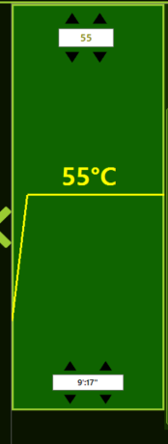

Figure 8. Reaction Step Settings

**Important Note:** The default temperature for the heat lid is set to 105°C, and it is recommended that users fix the heat lid temperature at this setting for PCR reactions. The ramp rate of the device is locked at 4°C/s to prolong the lifespan of the components, so users are not permitted to define a higher ramp rate. However, the device's algorithm allows for a ramp rate of up to 8°C/s under specific conditions without causing undue stress on the device. When necessary, the ramp rate may be reduced to a reasonable level to prevent excessive wear and tear on the device.

Variables for each step within a cycle differ from those for steps outside the cycle. In the steps within a cycle, instead of adding cycles, users can add Touch Step and Gradient Step. This allows the user to define a Touch Down step, a Touch Up step, or a Gradient step.

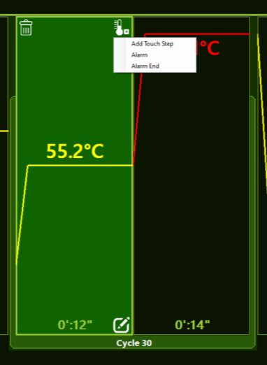

Figure 9. Variables for Steps within a Cycle

By clicking on the cycle border bar, the user can adjust the number of cycles. Additionally, by clicking on the three-dot icon, the user can create a new cycle, delete an existing cycle, or add a new step outside of the cycle.

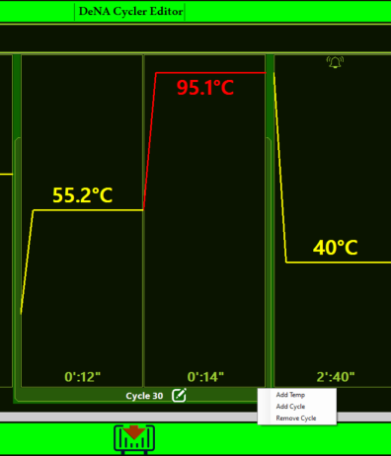

Figure 10. Editable Settings in the Cycle Border Editor

It is worth mentioning that users can define an incubation step as well. By clicking on the red tab located in the upper right corner of the software, an incubation step can be defined. The incubation step only has a temperature variable, and its duration is set to infinity by default.

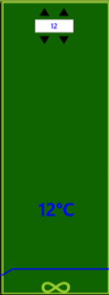 D:\نمایشگاه\دوره 10\ترموسایکلر ECO 32\manual pictures\10.png

Figure 11. Incubation Step**: In this step, only the temperature can be adjusted. The red tab on the left is for selecting the incubation step, while the right side is for configuring the settings of the incubation step.

Finally, after defining all the variables of a reaction, the user can save the file with a .DeNA extension, which will have a final size of less than one kilobyte.

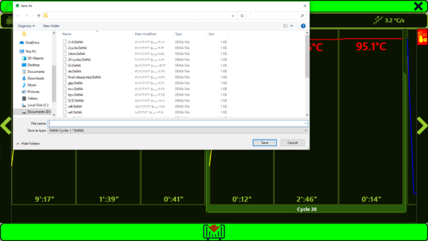

Figure 12. Saving a New Reaction. In order to run the reaction, it is necessary to first save it.

After clicking "Load to Thermo" and loading the reaction into the thermal cycler processor, the user needs to press the "Play" tab located in the lower center section of the software to start the reaction.

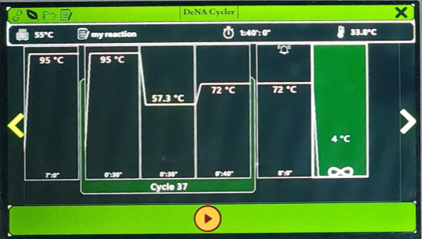

Figure 13. Running Menu of the DeNA Cycler Software. After initiating the reaction, you need to access the Running Menu and click on the red "Run Reaction" tab at the bottom of the reaction list to start the run.

Once the reaction starts, the temperature for each step will turn red, allowing the user to easily observe the current stage of the reaction through this color distinction.

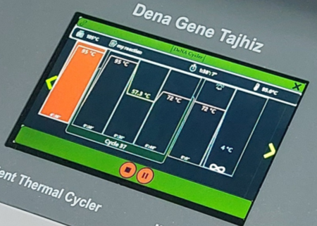

Figure 14. Step Color Change During the Reaction

In this figure, the color change of the step indicates the current stage of the reaction, allowing the user to easily determine which step the reaction is in.

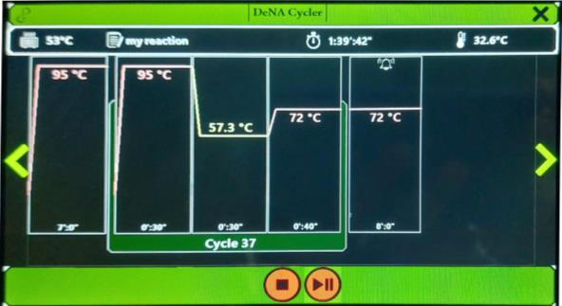During the running of the reaction, two tabs—Play/Stop and Pause—appear at the bottom of the reaction screen. Pressing Stop will completely terminate the reaction, while pressing Pause will create a pause in the reaction, allowing the user to resume it from the point where it was halted.

Figure 15. Pause During Reaction

When the reaction is paused, the pause symbol appears on the step where the reaction was halted.

# Touch Step

Touch Step is a different step in defining thermal cycler reactions. Touch Down is more common than Touch Up and is typically used for specific Annealing processes. Here, we describe how Touch Down works.

In this step, the user defines a temperature range and specifies how much temperature change should occur in each cycle until the desired final temperature is reached. The lower section includes the tab for configuring the duration of each step. As shown in the figure below, after defining the Touch Down step, a graph line is created corresponding to the number of cycles required for the temperature to decrease to the final Annealing temperature. After each cycle, one of the graph lines decreases until it reaches a single number.

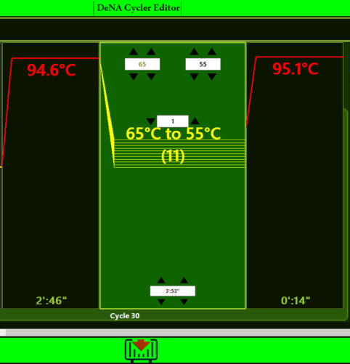

Figure 16. Touch Step Settings. The Touch Step can be either Touch Down or Touch Up.

# Gradient Step

Gradient temperature is a method for finding the optimal annealing temperature. In the DeNA Gen thermocyclers, the software is designed to allow the user to define a gradient of up to 8°C. To set this up, as shown in the figure below, the user first defines a gradient step and enters the detailed settings space. In this space, the user specifies the gradient range at the top, and the device automatically defines the gradient across different temperature zones.

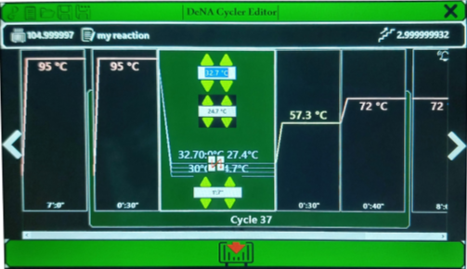

# Figure 17. Gradient Step Definition

# Shutting Down

# To turn off the device, the user should first close the reaction window. After closing this window, an additional menu will automatically appear with three options:

# 1. Edit Menu: Go to the editor menu.

# 2. Shut Down: Turn off the device.

# 3. Reaction Menu: Go to the reaction menu.

# By clicking on the Shut Down tab, as shown in the figure below, the user can power off the device. The shutdown process takes approximately 1 minute.

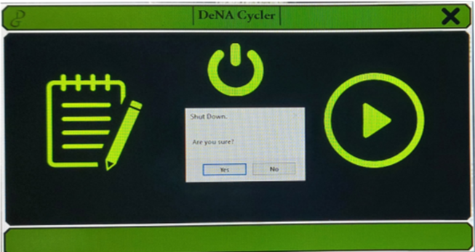

Figure 18. Device Shutdown Procedure

Note: If the reaction is not completed and the user proceeds to close the reaction window and then shut down the device, the computer will turn off. However, the device will continue with the reaction until it is fully completed and will automatically shut down afterward.

**Important Notes**

In the settings menu for each step, there are options for Alarm and Alarm End.

- Alarm: Emits a short beep as a warning and stops quickly.

- Alarm End: Causes the device to continuously beep until the end of the reaction is acknowledged.

Therefore, it is strongly recommended to set Alarm End only for the end of the reaction and not for intermediate steps within the reaction.



Figure 19. Alarm Definition Tab. This tab is present in all steps. It is advisable to set Alarm End only for the final step of the reaction and use Alarm for other steps if needed.

**Important Notes:**

-Heat Lid Temperature: The default heat lid temperature is set to 105°C to prevent evaporation of liquids within the reaction tube. Evaporation would concentrate the reactants and disrupt the reaction balance. However, the heat lid temperature can be adjusted between room temperature and 110°C. It is strongly recommended to keep the heat lid temperature at 105°C unless specific circumstances require a change.

- Pausing the Reaction: If a user realizes there is an error during the reaction and needs to stop it, they can press the **Pause** button to halt the PCR reaction. The reaction will stop, and after addressing the issue, the user can resume the reaction from where it was paused.

- Use of Oil: Due to the quality heat lid, it is advised not to use oil to cover the reaction unless absolutely necessary.

- Airflow and Ramp Settings: For optimal ramping performance, ensure that the device has proper airflow. If airflow is obstructed, the thermal cycler will not achieve proper ramping. When setting up the thermal cycler in a new location, follow these steps to check ventilation:

1. Turn on all devices near the thermal cycler.

2. Power on the thermal cycler and run a standard 30-minute protocol.

3. Check the temperature of the air being drawn into the device.

4. If the temperature exceeds 31°C, it indicates high-temperature air entering the device. The device should be relocated to a more suitable location.

- Avoid Heat Sources: Keep the thermal cycler away from heat sources such as radiators and air conditioners.

**Applications:**

The PCR device is used in three main areas: amplification and cloning, detection, and quantification, though its use in quantification is less common. Specific applications include:

- Nucleic Acid Amplification

- DNA Cloning

- Disease Detection

- Genotyping and Polymorphism

- Mutation Creation

- cDNA Library Construction

- Sequencing Analysis

- Forensic and Crime Investigation

**Warranty and After-Sales Service:**

- For any technical issues, contact only Denagene Tjhiz directly and avoid unauthorized personnel.

- The thermal cycler manufactured by Denagene Tajhiz comes with a 1-year warranty.

- The device also includes 10 years of after-sales service provided by Denagene Tajhiz.

**Documentation and Support**

To obtain support for the latest services and support information for all locations, go to:

[www.Denagene.com](http://www.Denagene.com)

At the website, you can:

• Access worldwide telephone and fax numbers to contact Technical Support and Sales facilities

• Search through frequently asked questions (FAQs)

• Submit a question directly to Technical Support

• Search for user documents, application notes, formulations, handbooks, certificates of analysis, citations, and other product support documents

• Obtain information about customer training

• Download software updates and patches

Contact Us:

[info@denagene.com](mailto:info@denagene.com)‌